**THE OXFORD COLLEGE OF SCIENCE**

**DEPARTMENT OF COMPUTER SCIENCE & APPLICATIONS**



(**AFFLIATED TO BANGALORE UNIVERSITY)**

**No.32, 17th B Main, Sector-IV, HSR Layout, Bangalore-560102**

PROJECT REPORT

ON

**BIKE RENTAL MANAGEMENT SYSTEM**

SUBMITTED BY

CHANDAN S

(17RNSB7030)

**Under The Guidance Of**

**MR. RATIKANTA MAJHI**

Bike Rental Management system project report submitted in partial fulfillment of the requirements of 6th semester BCA, Bangalore University

SEPTEMBER -2020

**THE OXFORD COLLEGE OF SCIENCE**

**DEPARTMENT OF COMPUTER SCIENCE & APPLICATIONS**



(**AFFLIATED TO BANGALORE UNIVERSITY)**

**No.32, 17th B Main, Sector-IV, HSR Layout, Bangalore-560102**

**CERTIFICATE**

*This is to certify that the report titled* ***Bike Rental System*** *is a bona fide record of work done by* ***Chandan S (17RNSB7030),*** *of The Oxford College of Science, Bangalore, in partial fulfillment of the requirements of 6th semester of BCA during the year 2020*

Head of the Department Project Guide

Valued By

1. Name: CHANDAN S

2. Register Number: 17RNSB7030

3. Exam center: The Oxford College of Science

4. Date of exam:

**DECLARATION**

I, hereby declare that this project work entitled **BIKE RENTAL SYSTEM** is submitted in partial fulfilment for the award of the degree of **BACHELOR OF COMPUTER APPLICATIONS** of Bangalore University.

I further declare that I have not submitted this project report either in part or in full to any other university for the award of any degree.

Date: Student Name: CHANDAN S

Place: The Oxford College of Science Reg. No: 17RNSB7030

**ACKNOWLEDGEMENT**

I’m thankful to **Dr.R.Kavya Shree**, principal of The Oxford College of Science, who provided us all the required facilities to accomplish the project in time.

I endure my Humble and sincere gratitude to **Dr. Sushil Kumar Sahoo, (HOD)** for his great encouragement and valuable support.

I offer my sincere to our guide **MR. Ratikanta Majhi** who has always given us a constant source of inspiration and encouragement during course of our project.

I would also like to mention the greatfullness of our parent’s blessings of which we are able to acess and enjoy such opportunities.

Last but not the least we thank our management and lab coordinator for providing us the support to complete the project. We would like thank each and everybody who supported us throughout the long and attention-consuming project.

**ABSTRACT**

As the name specifies “Bike Rental Management System”. This system is designed to help the customers to take bikes or two-wheelers on rent. When we go on any trip outside the town or country we want to be free of time so instead of going through metros and taxis we prefer to have our own vehicle for rent. Using this system customers who want to take bikes on rent can register themselves as renters and can take any bike on rent.

This particular project deals with the problems on managing renting of bike and avoids the problems, which occur when carried manually. Identification of the drawbacks of the existing system leads to the designing of computerized system that will be compatible to the existing system with the system, which is more user friendly, and more GUI oriented. We can improve the efficiency of the system, thus overcome the drawbacks of the existing system.

* Less human error
* Strength and strain of manual labour can be reduced
* High security
* Data consistency
* Easy to handle
* Easy data updating
* Easy record keeping.

|  |  |  |
| --- | --- | --- |
| **SL.NO** | **INDEX** | **PG.NO** |
| **1** | **Introduction**   * 1. **Problem Statements**   **1.2 Existing System**  **1.1.1 Description**  **1.1.2 Drawbacks** | **1** |
| **2** | **System Requirements**  **2.1Proposed System**  **2.2 Hardware and software Requirements**  **2.3 Tools survey**  **2.4 Software development approach** | **3**  **5**  **6**  **15** |
| **3** | **Design Specification**  **Introduction to Design**  **3.2.1 Data Flow Diagram**  **Level zero DFD**  **Level One DFD** | **19**  **20**  **21**  **22** |
| **4** | **Implementation details**  **4.1 Coding**  **4.2 Screenshots** | **25**  **24**  **55** |
| **5** | **Testing**  **5.1 test cases** | **64** |
| **6** | **Conclusion** | **66** |
| **7** | **Future Enhancement** | **68** |
| **8** | **Bibliography** | **69** |

1. **INTRODUCTION**

**1. Introduction**

**1.1 Problem Statement**

**The current system is manual and it is time consuming. It is also cost ineffective, and average return is low and diminishing. Currently, customer can call or walk-in order to rent or reserve a vehicle. The staff of the company will check their file to see which vehicle is availabe for rental.**

**The current system is error prone and customers are dissatisfied. The goal of this project is to automate vehicle rental and reservation so that customers do not need to walk-in or call in order to reseve a vehicle. There is a huge amount of paper work involved in the process.** This particular project deals with the problems on managing a bike rental system and avoids the problems which occur when carried manually Identification of the drawbacks of the existing system leads to the designing of computerized system that will be compatible to the existing system with the system which is more user friendly and more GUI oriented. We can improve the efficiency of the system, thus overcome the drawbacks of the existing system.

**1.2 EXISTING AND PROPOSED SYSTEM**

Existing System:

**The current system is manual and it is time consuming. It is also cost ineffective, and average return is low and diminishing. Currently, customer can call or walk-in order to rent or reserve a vehicle. The staff of the company will check their file to see which vehicle is availabe for rental.**

**The current system is error prone and customers are dissatisfied. The goal of this project is to automate vehicle rental and reservation so that customers do not need to walk-in or call in order to reseve a vehicle. There is a huge amount of paper work involved in the process.**

Drawbacks of existing system:

* All Work are done manually.
* **It does not ensures security of every record.**
* **It increases the redundancy of data and gives various facilities.**
* **It leads to loss of data.**
* **It is time consuimg and sometimes there is no availability of bikes.**

**1.2 Proposed system**

* **To automate the existing Bike Rental Management system in the current environment.**
* **To decrease the paperwork and enable the process with efficient, reliable record maintenance by using centralized database, thereby reducing chances of data loss.**
* **To provide for an automated Bike rental management system that intelligently adapts to policy of the Bikes and allows customer to check availiabiity of Bikes and then get booked.**

**Enhancements:**

**The main objective of the Bike Rental Management System is to enhance and upgrade the existing system by increasing the efficiency and effectiveness. The software improves the working methods by replacing manual system with the computer-based system.**

**Automation:**

**The Bike Rental Management system automates every activity of the manual system and increases its throughput. Thus, the response time of the system is very less and it works very fast.**

**Accuracy:**

**The Bike Rental Management system provides the user very quick response with very accurate information regarding their room and booking, any details or system in an accurate manner, as when required.**

**User friendly:**

**The website Bike Rental management system has very friendly interface.Thus the users will feel very easy to work on it. The software provides the accuracy along with the pleasant interface. Make the present manual system more interactive, speedy and user friendly.**

**Availability:**

**The Booking reports of the customers rented bikes can be retried as and when required.**

**Thus, there is no delay in the availability of any information, whatever needed, can be captured very quickly and easily.**

**SYSTEM REQUIREMENTS**

**2. System Requirement**

2.1 Hardware and Software Requirements

**Hardware Requirements**

* Processor : Intel Pentium and above
* Ram : 2GB or above
* Cache Memory : 128 KB or above
* Printer : Compatible
* Screen Resolution : 1024*768

**Software Requirements**

* Operating System : Windows 7 and above
* Web Browser : Google Chrome or firefox
* Xamp or wamp control panel.
* Visual studio code editor or notepad ++

2.2 Tool Surevey

* **PHP**

## What is PHP?

* PHP is an acronym for "PHP: Hypertext Preprocessor"
* PHP is a widely-used, open source scripting language
* PHP scripts are executed on the server
* PHP is free to download and use

## What is a PHP File?

* PHP files can contain text, HTML, CSS, JavaScript, and PHP code
* PHP code are executed on the server, and the result is returned to the browser as plain HTML
* PHP files have extension ".php"

## What Can PHP Do?

* PHP can generate dynamic page content
* PHP can create, open, read, write, delete, and close files on the server
* PHP can collect form data
* PHP can send and receive cookies
* PHP can add, delete, modify data in your database
* PHP can be used to control user-access
* PHP can encrypt data

With PHP you are not limited to output HTML. You can output images, PDF files, and even Flash movies. You can also output any text, such as XHTML and XML.

## Why PHP?

* PHP runs on various platforms (Windows, Linux, Unix, Mac OS X, etc.)

PHP started out as a small open source project that evolved as more and more people found out how useful it was. Rasmus Lerdorf unleashed the first version of PHP way back in 1994.

* PHP is a recursive acronym for "PHP: Hypertext Preprocessor".
* PHP is a server side scripting language that is embedded in HTML. It is used to manage dynamic content, databases, session tracking, even build entire e-commerce sites.
* It is integrated with a number of popular databases, including MySQL, PostgreSQL, Oracle, Sybase, Informix, and Microsoft SQL Server.
* PHP is pleasingly zippy in its execution, especially when compiled as an Apache module on the Unix side. The MySQL server, once started, executes even very complex queries with huge result sets in record-setting time.
* PHP supports a large number of major protocols such as POP3, IMAP, and LDAP. PHP4 added support for Java and distributed object architectures (COM and CORBA), making n-tier development a possibility for the first time.
* PHP is forgiving: PHP language tries to be as forgiving as possible.
* PHP Syntax is C-Like.

## Common uses of PHP

* PHP performs system functions, i.e. from files on a system it can create, open, read, write, and close them.
* PHP can handle forms, i.e. gather data from files, save data to a file, through email you can send data, return data to the user.
* You add, delete, modify elements within your database through PHP.
* Access cookies variables and set cookies.
* Using PHP, you can restrict users to access some pages of your website.
* It can encrypt data.

## Characteristics of PHP

Five important characteristics make PHP's practical nature possible −

* Simplicity
* Efficiency
* Security
* Flexibility
* Familiarity
* PHP is compatible with almost all servers used today (Apache, IIS, etc.)
* PHP supports a wide range of databases
* PHP is free. Download it from the official PHP resource: [www.php.net](http://www.php.net/)
* PHP is easy to learn and runs efficiently on the server side
* **CSS**

**C**ascading **S**tyle **S**heets, fondly referred to as CSS, is a simple design language intended to simplify the process of making web pages presentable.

CSS handles the look and feel part of a web page. Using CSS, you can control the color of the text, the style of fonts, the spacing between paragraphs, how columns are sized and laid out, what background images or colors are used, layout designs, variations in display for different devices and screen sizes as well as a variety of other effects.

CSS is easy to learn and understand but it provides powerful control over the presentation of an HTML document. Most commonly, CSS is combined with the markup languages HTML or XHTML.

## Advantages of CSS

* **CSS saves time** − You can write CSS once and then reuse same sheet in multiple HTML pages. You can define a style for each HTML element and apply it to as many Web pages as you want.
* **Pages load faster** − If you are using CSS, you do not need to write HTML tag attributes every time. Just write one CSS rule of a tag and apply it to all the occurrences of that tag. So less code means faster download times.
* **Easy maintenance** − To make a global change, simply change the style, and all elements in all the web pages will be updated automatically.
* **Superior styles to HTML** − CSS has a much wider array of attributes than HTML, so you can give a far better look to your HTML page in comparison to HTML attributes.
* **Multiple Device Compatibility** − Style sheets allow content to be optimized for more than one type of device. By using the same HTML document, different versions of a website can be presented for handheld devices such as PDAs and cell phones or for printing.
* **Global web standards** − Now HTML attributes are being deprecated and it is being recommended to use CSS. So it’s a good idea to start using CSS in all the HTML pages to make them compatible to future browsers.

## Who Creates and Maintains CSS?

CSS is created and maintained through a group of people within the W3C called the CSS Working Group. The CSS Working Group creates documents called specifications. When a specification has been discussed and officially ratified by the W3C members, it becomes a recommendation.

These ratified specifications are called recommendations because the W3C has no control over the actual implementation of the language. Independent companies and organizations create that software.

## CSS Versions

Cascading Style Sheets level 1 (CSS1) came out of W3C as a recommendation in December 1996. This version describes the CSS language as well as a simple visual formatting model for all the HTML tags.

CSS2 became a W3C recommendation in May 1998 and builds on CSS1. This version adds support for media-specific style sheets e.g. printers and aural devices, downloadable fonts, element positioning and tables.

* **JAVA SCRIPT**

## What is JavaScript?

Javascript is a dynamic computer programming language. It is lightweight and most commonly used as a part of web pages, whose implementations allow client-side script to interact with the user and make dynamic pages. It is an interpreted programming language with object-oriented capabilities.

JavaScript was first known as **LiveScript,** but Netscape changed its name to JavaScript, possibly because of the excitement being generated by Java. JavaScript made its first appearance in Netscape 2.0 in 1995 with the name **LiveScript**. The general-purpose core of the language has been embedded in Netscape, Internet Explorer, and other web browsers.

The [ECMA-262 Specification](http://www.ecma-international.org/publications/index.html) defined a standard version of the core JavaScript language.

* JavaScript is a lightweight, interpreted programming language.
* Designed for creating network-centric applications.
* Complementary to and integrated with Java.
* Complementary to and integrated with HTML.
* Open and cross-platform

## Client-side JavaScript

Client-side JavaScript is the most common form of the language. The script should be included in or referenced by an HTML document for the code to be interpreted by the browser.

It means that a web page need not be a static HTML, but can include programs that interact with the user, control the browser, and dynamically create HTML content.

The JavaScript client-side mechanism provides many advantages over traditional CGI server-side scripts. For example, you might use JavaScript to check if the user has entered a valid e-mail address in a form field.

The JavaScript code is executed when the user submits the form, and only if all the entries are valid, they would be submitted to the Web Server.

JavaScript can be used to trap user-initiated events such as button clicks, link navigation, and other actions that the user initiates explicitly or implicitly.

## Advantages of JavaScript

The merits of using JavaScript are −

* **Less server interaction** − you can validate user input before sending the page off to the server. This saves server traffic, which means less load on your server.
* **Immediate feedback to the visitors** − they don't have to wait for a page reload to see if they have forgotten to enter something.
* **Increased interactivity** − you can create interfaces that react when the user hovers over them with a mouse or activates them via the keyboard.
* **Richer interfaces** − you can use JavaScript to include such items as drag-and-drop components and sliders to give a Rich Interface to your site visitors.
* **JQUERY**

## JQuery

If you’ve spent any time at all trying to add dynamic functionality to your pages (as well as figure out browser differences), you’ve found that you’re constantly following a pattern of selecting an element or group of elements and operating upon those elements in some fashion.

You could be hiding or revealing the elements, adding a CSS class to them, animating them, or modifying their attributes.

Using raw JavaScript can result in dozens of lines of code for each of these tasks. The creators of jQuery specifically created the library to make common tasks trivial.

Jquery is one of the most popular JavaScript libraries around and was created by John Resig during his college days at the Rochester Institute of Technology.

The core features of Jquery

• Gives developers a common set of functions for all browsers.  
• Uses selectors which is an expression for identifying target elements on a page that allows us to easily identify and grab the elements we need  
• Gives access to page elements without having to wait for all images to load in place of using the browser’s onload event, which delays anything you do until the page is fully loaded.  
• Contains enhancements to basic JavaScript constructs such as iteration and array manipulation.

* **MY SQL**

## MySQL Database

MySQL is a fast, easy-to-use RDBMS being used for many small and big businesses. MySQL is developed, marketed and supported by MySQL AB, which is a Swedish company. MySQL is becoming so popular because of many good reasons −

* MySQL is released under an open-source license. So you have nothing to pay to use it.
* MySQL is a very powerful program in its own right. It handles a large subset of the functionality of the most expensive and powerful database packages.
* MySQL uses a standard form of the well-known SQL data language.
* MySQL works on many operating systems and with many languages including PHP, PERL, C, C++, JAVA, etc.
* MySQL works very quickly and works well even with large data sets.
* MySQL is very friendly to PHP, the most appreciated language for web development.
* MySQL supports large databases, up to 50 million rows or more in a table. The default file size limit for a table is 4GB, but you can increase this (if your operating system can handle it) to a theoretical limit of 8 million terabytes (TB).
* MySQL is customizable. The open-source GPL license allows programmers to modify the MySQL software to fit their own specific environments.

**PhpMyAdmin**

It is an open source tool and also, it is free written in PHP, XHTML, CSS, and JavaScript planned to manage the administration of MySQL by using of a web. It is able to perform various missions like creating, modifying databases, tables, fields, executing SQL statements or managing and supervise users. PhpMyAdmin is being translated into 72 languages in order to make the usage easy to a wide domain of people and it supports both LTR and RTL languages.

Following is some features of the phpMyAdmin,

* It is web interface

* It administrates multiple severs

* It is able to create PDF graphics of the database layout

* Importing data from SQL and CSV

* Export data to different formats such as SQL, PDF, CSV, XML and others

**2.3 SOFTWARE DEVELOPMENT APPROACH**

**The section of the software requirements is proposed to fill in as a guide that clarifies the centrality of producing compact prerequisites for a versatile application and in addition, depicts the procedure of necessary definition. The target group of this report is anybody with pre deals and additionally delivery oriented business including the individuals who are in charge of characterizing necessities.**

**Software requirements specification records and portrays all the key features of an application and clarifies that the objective application ought to have the capcity to perform the significance of having an appropriate necessity detail cant be exaggerated numerous applications come up short on the grounds.**

**A particular is an archive that gives an entire portrayal of the usefulness of the specialized arrangement the detailed answers the accompanying inquiries: how does the application work? How does the costumer/shopper is should be tended to in the application? The most critical goal of the necessary detail practice is to characterize the costumer/shopper issue so that the UI plan and advance group can begin application outline and fabricate exercises.**

**The principle input expected to make a prerequisite detail is a mode information separated from shopper/costumer: the costumers present needs, issues that require arrangements, purchase patterns and forth since the detail is such a basic component in the application creation is utilized by the people engaged with the undertaking.**

**The implementation team, user experience interface designers, the advertising group and the testing group to give some example assistants.**

**Users**

**According to the application profile, this is management software, which covers inventory, various login shells, records etc.**

**FUNCTIONAL REQUIRMENTS:**

**Functional requirements has been described in this project based on the highlights and functionalities of the application. It is, for the most part, a smart thought to begin with the generally unique state useful prerequisite that can be separated into a few lower-level necessities.**

**Operational prerequisites portray how the system, will interact with the operations personnel. Recognize inclinations from necessities. Prerequisites depend on the business needs provided by the clients.**

**Inclinations are most certainly not in the event that, for instance, the client communicates a want for the sub second reaction yet does not have the email marketing related explanation behind requiring it, that requirement is an inclination.**

* **NON FUNCTIONAL REQUIRMENTS:**

**Non functional requirements presents an efficient and down to the business way to deal with building quality into programming systems. System must display programming quality properties**

**.**

**None the less such non functional requirements are hard address in numerous undertakings, despite the fact that there are numerous strategies to meet useful prerequisites with a specific end goal to give wanted usefulness.**

**This is especially valid since the non functional requirements for every system associate with each other, broadly affect the system and might be subjective.**

**To empower designers to deliberately manage a systems different non functional requirements, this section displays the non functional requirement system.**

**Performance:**

* **Portray the prerequisites for the accompanying:**
* **Response time for the inquiries and updates**
* **Throughput**
* **The expected rate of client action (for instance, number of exchanges every hour, day ,or month )**

**Adaption to non critical failure:**

**Adaption to non critical failure is the capacity to remain mostly operational amid a disappointment, portray the following in this area:**

* **Which capacities don’t should be accessible consistently?**
* **If a segment comes up short, what (assuming any) capacities should the application keeps on providing?**

**3. DESIGN SPECIFICATION**

**SYSTEM PRESCRIPTIVE**

In accordance to the system prescriptive, software development as a rule, continues in one of the two ways: either the software engineer works alone in outlining, actualizing and testing a product system, or he is the individual from the gathering of from three up to a few hundred, cooperating on a vast programming system. In spite of the fact that product designing grasps both methodologies, here we are integrated basically in substantial scale programme advancement. It is the basic connection among outline and necessities building as it is distinguishes the fundamental basic parts in a system and connection between them.

**ARCHITECTURE DIAGRAM**

Architecture diagram is all about seeing how a system ought to be sorted out and outlining the general structure of the system. In the model of the product improvement process as appeared building process it is the basic connection amongst plan and necessities designing as it recognizes the basic fundamental segments in a system and connection between them.

In the process it is by and large acknowledged that at the beginning time of the improvement procedure ought to be worried about setting up a general system design. Incremental advancement of structures is not generally effective. While restoring segments in light of changes is typically moderately simple, refactoring a system engineering is probably going to be costly.

By and by there is a critical cover between the procedure and prerequisites building and compositional plan. In a perfect world a system determination ought to be exclude any outline data .this is impossible side from ought little systems.

**Data flow diagram:**

**Data flow diagram, (DFD) maps out the stream of data to any procedure or framework. It utilizes characterized images rectangles circle and arrows, plus short text labels to show input , output , storage point and the route between the each destination to demonstrate the information input , yields, stockpiling focuses and the course between every goal information flowchart can go from basic , even hand drawn process and diagrams to inside out , multi level DFD’s that delve dynamically more into how the information is dealt with they can be utilized to break the current system model another one like all the best outlines and diagrams, a DFD can outwardly say things that would be difficult to clarify in words and they work in both specialized and non technical crowds from designer to CEO.**

DATA FLOW DIAGRAM

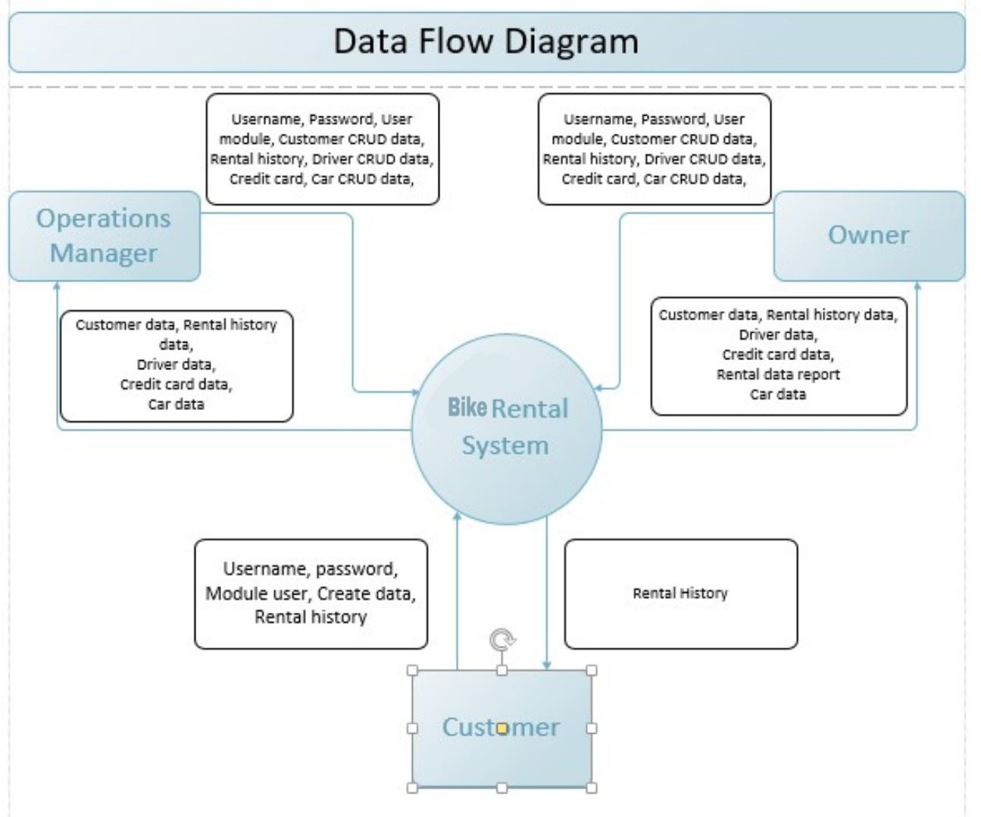

**Level-0 Diagram**

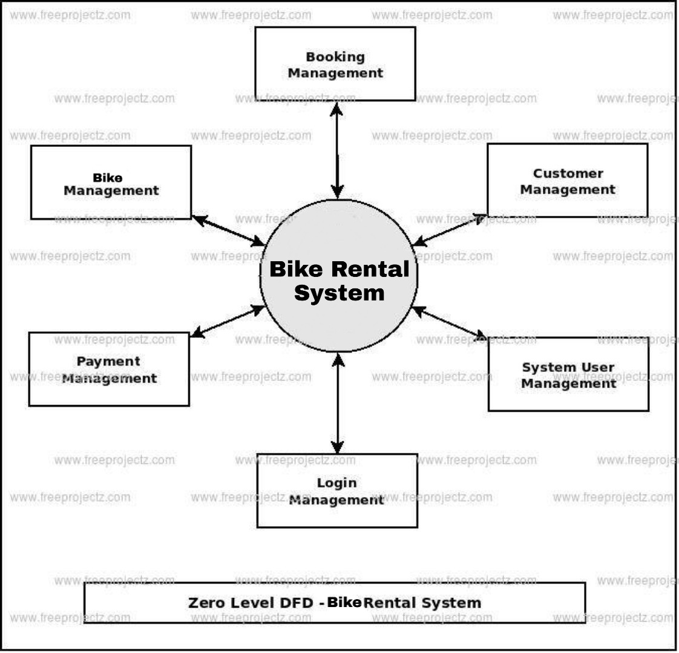

**Level-1 Diagram**

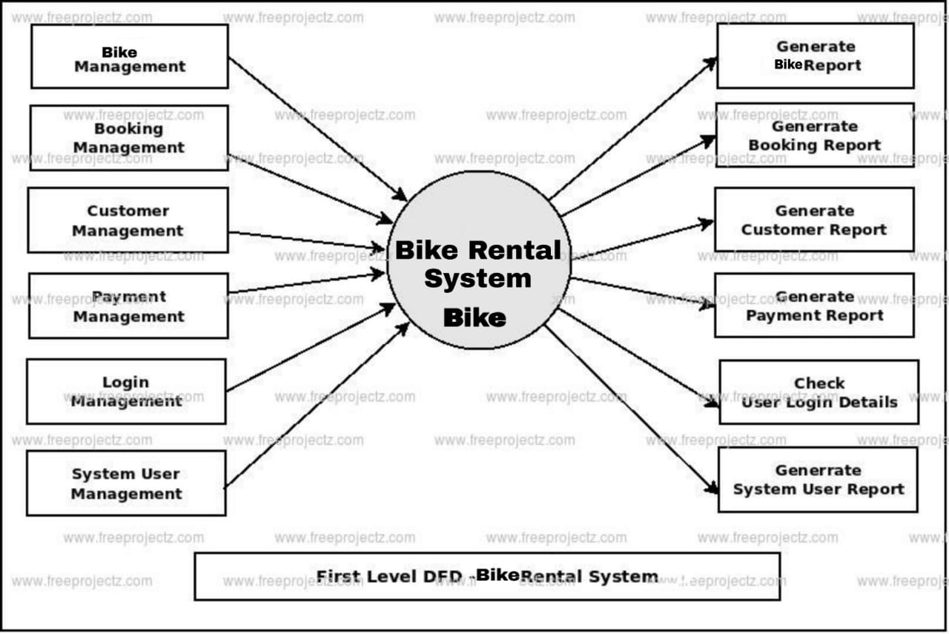

IMPLEMENTATION DETAILS

**4.1 CODING**

**Index.php**

<?php

session_start();

include('includes/config.php');

error_reporting(0);

?>

<!DOCTYPE HTML>

<html lang="en">

<head>

<meta http-equiv="Content-Type" content="text/html; charset=utf-8">

<meta http-equiv="X-UA-Compatible" content="IE=edge">

<meta name="viewport" content="width=device-width,initial-scale=1">

<meta name="keywords" content="">

<meta name="description" content="">

<title>Bike Rental Portal</title>

<!--Bootstrap -->

<link rel="stylesheet" href="assets/css/bootstrap.min.css" type="text/css">

<link rel="stylesheet" href="assets/css/styles.css" type="text/css">

<link rel="stylesheet" href="assets/css/owl.carousel.css" type="text/css">

<link rel="stylesheet" href="assets/css/owl.transitions.css" type="text/css">

<link href="assets/css/slick.css" rel="stylesheet">

<link href="assets/css/bootstrap-slider.min.css" rel="stylesheet">

<link href="assets/css/font-awesome.min.css" rel="stylesheet">

<link rel="stylesheet" id="switcher-css" type="text/css" href="assets/switcher/css/switcher.css" media="all" />

<link rel="alternate stylesheet" type="text/css" href="assets/switcher/css/red.css" title="red" media="all" data-default-color="true" />

<link rel="alternate stylesheet" type="text/css" href="assets/switcher/css/orange.css" title="orange" media="all" />

<link rel="alternate stylesheet" type="text/css" href="assets/switcher/css/blue.css" title="blue" media="all" />

<link rel="alternate stylesheet" type="text/css" href="assets/switcher/css/pink.css" title="pink" media="all" />

<link rel="alternate stylesheet" type="text/css" href="assets/switcher/css/green.css" title="green" media="all" />

<link rel="alternate stylesheet" type="text/css" href="assets/switcher/css/purple.css" title="purple" media="all" />

<link rel="apple-touch-icon-precomposed" sizes="144x144" href="assets/images/favicon-icon/apple-touch-icon-144-precomposed.png">

<link rel="apple-touch-icon-precomposed" sizes="114x114" href="assets/images/favicon-icon/apple-touch-icon-114-precomposed.html">

<link rel="apple-touch-icon-precomposed" sizes="72x72" href="assets/images/favicon-icon/apple-touch-icon-72-precomposed.png">

<link rel="apple-touch-icon-precomposed" href="assets/images/favicon-icon/apple-touch-icon-57-precomposed.png">

<link rel="shortcut icon" href="assets/images/favicon-icon/24x24.png">

<link href="https://fonts.googleapis.com/css?family=Lato:300,400,700,900" rel="stylesheet">

</head>

<body>

<!-- Start Switcher -->

<?php include('includes/colorswitcher.php');?>

<!-- /Switcher -->

<!--Header-->

<?php include('includes/header.php');?>

<!-- /Header -->

<!-- Banners -->

<section id="banner" class="banner-section">

<div class="container">

<div class="div_zindex">

<div class="row">

<div class="col-md-5 col-md-push-7">

<div class="banner_content">

<h1>Find Your Perfect bike</h1>

<p>We have more than a thousand bikes for you to choose. </p>

<a href="#" class="btn">Read More <span class="angle_arrow"><i class="fa fa-angle-right" aria-hidden="true"></i></span></a> </div>

</div>

</div>

</div>

</div>

</section>

<!-- /Banners -->

<!-- Resent Cat-->

<section class="section-padding gray-bg">

<div class="container">

<div class="section-header text-center">

<h2>Find the Best <span>Bike For You</span></h2>

<p>You will be able to fully enjoy your holiday and your ride! Any problems? Our passionate team will be happy to help you!! No waste of time during your holidays to find a rental point on the spot! No language barrier, thanks to our multilingual team! At the same price you would pay on the spot! We have best bikes with best deals</p>

</div>

<div class="row">

<!-- Nav tabs -->

<div class="recent-tab">

<ul class="nav nav-tabs" role="tablist">

<li role="presentation" class="active"><a href="#resentnewcar" role="tab" data-toggle="tab">New Bike</a></li>

</ul>

</div>

<!-- Recently Listed New Cars -->

<div class="tab-content">

<div role="tabpanel" class="tab-pane active" id="resentnewcar">

<?php $sql = "SELECT tblvehicles.VehiclesTitle,tblbrands.BrandName,tblvehicles.PricePerDay,tblvehicles.FuelType,tblvehicles.ModelYear,tblvehicles.id,tblvehicles.SeatingCapacity,tblvehicles.VehiclesOverview,tblvehicles.Vimage1 from tblvehicles join tblbrands on tblbrands.id=tblvehicles.VehiclesBrand";

$query = $dbh -> prepare($sql);

$query->execute();

$results=$query->fetchAll(PDO::FETCH_OBJ);

$cnt=1;

if($query->rowCount() > 0)

{

foreach($results as $result)

{

?>

<div class="col-list-3">

<div class="recent-car-list">

<div class="car-info-box"> <a href="vehical-details.php?vhid=<?php echo htmlentities($result->id);?>"><img src="admin/img/vehicleimages/<?php echo htmlentities($result->Vimage1);?>" class="img-responsive" alt="image"></a>

<ul>

<li><i class="fa fa-car" aria-hidden="true"></i><?php echo htmlentities($result->FuelType);?></li>

<li><i class="fa fa-calendar" aria-hidden="true"></i><?php echo htmlentities($result->ModelYear);?> Model</li>

<li><i class="fa fa-user" aria-hidden="true"></i><?php echo htmlentities($result->SeatingCapacity);?> seats</li>

</ul>

</div>

<div class="car-title-m">

<h6><a href="vehical-details.php?vhid=<?php echo htmlentities($result->id);?>"><?php echo htmlentities($result->BrandName);?> , <?php echo htmlentities($result->VehiclesTitle);?></a></h6>

<span class="price">$<?php echo htmlentities($result->PricePerDay);?> /Day</span>

</div>

<div class="inventory_info_m">

<p><?php echo substr($result->VehiclesOverview,0,70);?></p>

</div>

</div>

</div>

<?php }}?>

</div>

</div>

</div>

</section>

<!-- /Resent Cat -->

<!-- Fun Facts-->

<section class="fun-facts-section">

<div class="container div_zindex">

<div class="row">

<div class="col-lg-3 col-xs-6 col-sm-3">

<div class="fun-facts-m">

<div class="cell">

<h2><i class="fa fa-calendar" aria-hidden="true"></i>1+</h2>

<p>Years In Business</p>

</div>

</div>

</div>

<div class="col-lg-3 col-xs-6 col-sm-3">

<div class="fun-facts-m">

<div class="cell">

<h2><i class="fa fa-motorcycle " aria-hidden="true"></i>100+</h2>

<p>New Bikes For Rent</p>

</div>

</div>

</div>

<div class="col-lg-3 col-xs-6 col-sm-3">

<div class="fun-facts-m">

<div class="cell">

<h2><i class="fa fa-motorcycle " aria-hidden="true"></i>99+</h2>

<p>Used Bikes For Rent</p>

</div>

</div>

</div>

<div class="col-lg-3 col-xs-6 col-sm-3">

<div class="fun-facts-m">

<div class="cell">

<h2><i class="fa fa-user-circle-o" aria-hidden="true"></i>100+</h2>

<p>Satisfied Customers</p>

</div>

</div>

</div>

</div>

</div>

<!-- Dark Overlay-->

<div class="dark-overlay"></div>

</section>

<!-- /Fun Facts-->

<!--Testimonial -->

<section class="section-padding testimonial-section parallex-bg">

<div class="container div_zindex">

<div class="section-header white-text text-center">

<h2>Our Satisfied <span>Customer's Review</span></h2>

</div>

<div class="row">

<div id="testimonial-slider">

<?php

$tid=1;

$sql = "SELECT tbltestimonial.Testimonial,tblusers.FullName from tbltestimonial join tblusers on tbltestimonial.UserEmail=tblusers.EmailId where tbltestimonial.status=:tid";

$query = $dbh -> prepare($sql);

$query->bindParam(':tid',$tid, PDO::PARAM_STR);

$query->execute();

$results=$query->fetchAll(PDO::FETCH_OBJ);

$cnt=1;

if($query->rowCount() > 0)

{

foreach($results as $result)

{ ?>

<div class="testimonial-m">

<div class="testimonial-img"> <img src="assets/images/cat-profile.png" alt="" /> </div>

<div class="testimonial-content">

<div class="testimonial-heading">

<h5><?php echo htmlentities($result->FullName);?></h5>

<p><?php echo htmlentities($result->Testimonial);?></p>

</div>

</div>

</div>

<?php }} ?>

</div>

</div>

</div>

<!-- Dark Overlay-->

<div class="dark-overlay"></div>

</section>

<!-- /Testimonial-->

<!--Footer -->

<?php include('includes/footer.php');?>

<!-- /Footer-->

<!--Back to top-->

<div id="back-top" class="back-top"> <a href="#top"><i class="fa fa-angle-up" aria-hidden="true"></i> </a> </div>

<!--/Back to top-->

<!--Login-Form -->

<?php include('includes/login.php');?>

<!--/Login-Form -->

<!--Register-Form -->

<?php include('includes/registration.php');?>

<!--/Register-Form -->

<!--Forgot-password-Form -->

<?php include('includes/forgotpassword.php');?>

<!--/Forgot-password-Form -->

<!-- Scripts -->

<script src="assets/js/jquery.min.js"></script>

<script src="assets/js/bootstrap.min.js"></script>

<script src="assets/js/interface.js"></script>

<!--Switcher-->

<script src="assets/switcher/js/switcher.js"></script>

<!--bootstrap-slider-JS-->

<script src="assets/js/bootstrap-slider.min.js"></script>

<!--Slider-JS-->

<script src="assets/js/slick.min.js"></script>

<script src="assets/js/owl.carousel.min.js"></script>

</body>

<!-- Mirrored from themes.webmasterdriver.net/carforyou/demo/index.html by HTTrack Website Copier/3.x [XR&CO'2014], Fri, 16 Jun 2017 07:22:11 GMT -->

</html>

**Admin/index.php**

<?php

session_start();

include('includes/config.php');

if(isset($_POST['login']))

{

$email=$_POST['username'];

$password=md5($_POST['password']);

$sql ="SELECT UserName,Password FROM admin WHERE UserName=:email and Password=:password";

$query= $dbh -> prepare($sql);

$query-> bindParam(':email', $email, PDO::PARAM_STR);

$query-> bindParam(':password', $password, PDO::PARAM_STR);

$query-> execute();

$results=$query->fetchAll(PDO::FETCH_OBJ);

if($query->rowCount() > 0)

{

$_SESSION['alogin']=$_POST['username'];

echo "<script type='text/javascript'> document.location = 'change-password.php'; </script>";

} else{

echo "<script>alert('Invalid Details');</script>";

}

}

?>

<!doctype html>

<html lang="en" class="no-js">

<head>

<meta charset="UTF-8">

<meta http-equiv="X-UA-Compatible" content="IE=edge">

<meta name="viewport" content="width=device-width, initial-scale=1, minimum-scale=1, maximum-scale=1">

<meta name="description" content="">

<meta name="author" content="">

<title>Bike Rental Portal | Admin Login</title>

<link rel="stylesheet" href="css/font-awesome.min.css">

<link rel="stylesheet" href="css/bootstrap.min.css">

<link rel="stylesheet" href="css/dataTables.bootstrap.min.css">

<link rel="stylesheet" href="css/bootstrap-social.css">

<link rel="stylesheet" href="css/bootstrap-select.css">

<link rel="stylesheet" href="css/fileinput.min.css">

<link rel="stylesheet" href="css/awesome-bootstrap-checkbox.css">

<link rel="stylesheet" href="css/style.css">

</head>

<body>

<div class="login-page bk-img" style="background-image: url(img/adminlogin0.jpg);">

<div class="form-content">

<div class="container">

<div class="row">

<div class="col-md-6 col-md-offset-3">

<h1 class="text-center text-bold text-light mt-4x">ADMIN LOGIN</h1>

<div class="well row pt-2x pb-3x bk-light">

<div class="col-md-8 col-md-offset-2">

<form method="post">

<label for="" class="text-uppercase text-sm">Your Username </label>

<input type="text" placeholder="Username" name="username" class="form-control mb">

<label for="" class="text-uppercase text-sm">Password</label>

<input type="password" placeholder="Password" name="password" class="form-control mb">

<button class="btn btn-primary btn-block" name="login" type="submit">LOGIN</button>

</form>

</div>

</div>

</div>

</div>

</div>

</div>

</div>

<!-- Loading Scripts -->

<script src="js/jquery.min.js"></script>

<script src="js/bootstrap-select.min.js"></script>

<script src="js/bootstrap.min.js"></script>

<script src="js/jquery.dataTables.min.js"></script>

<script src="js/dataTables.bootstrap.min.js"></script>

<script src="js/Chart.min.js"></script>

<script src="js/fileinput.js"></script>

<script src="js/chartData.js"></script>

<script src="js/main.js"></script>

</body>

</html>

**Bike-listing.php**

<?php

session_start();

include('includes/config.php');

error_reporting(0);

?>

<!DOCTYPE HTML>

<html lang="en">

<head>

<meta http-equiv="Content-Type" content="text/html; charset=utf-8">

<meta http-equiv="X-UA-Compatible" content="IE=edge">

<meta name="viewport" content="width=device-width,initial-scale=1">

<meta name="keywords" content="">

<meta name="description" content="">

<title>Bike Rental Portal | Bike Listing</title>

<!--Bootstrap -->

<link rel="stylesheet" href="assets/css/bootstrap.min.css" type="text/css">

<!--Custome Style -->

<link rel="stylesheet" href="assets/css/styles.css" type="text/css">

<!--OWL Carousel slider-->

<link rel="stylesheet" href="assets/css/owl.carousel.css" type="text/css">

<link rel="stylesheet" href="assets/css/owl.transitions.css" type="text/css">

<!--slick-slider -->

<link href="assets/css/slick.css" rel="stylesheet">

<!--bootstrap-slider -->

<link href="assets/css/bootstrap-slider.min.css" rel="stylesheet">

<!--FontAwesome Font Style -->

<link href="assets/css/font-awesome.min.css" rel="stylesheet">

<!-- SWITCHER -->

<link rel="stylesheet" id="switcher-css" type="text/css" href="assets/switcher/css/switcher.css" media="all" />

<link rel="alternate stylesheet" type="text/css" href="assets/switcher/css/red.css" title="red" media="all" data-default-color="true" />

<link rel="alternate stylesheet" type="text/css" href="assets/switcher/css/orange.css" title="orange" media="all" />

<link rel="alternate stylesheet" type="text/css" href="assets/switcher/css/blue.css" title="blue" media="all" />

<link rel="alternate stylesheet" type="text/css" href="assets/switcher/css/pink.css" title="pink" media="all" />

<link rel="alternate stylesheet" type="text/css" href="assets/switcher/css/green.css" title="green" media="all" />

<link rel="alternate stylesheet" type="text/css" href="assets/switcher/css/purple.css" title="purple" media="all" />

<!-- Fav and touch icons -->

<link rel="apple-touch-icon-precomposed" sizes="144x144" href="assets/images/favicon-icon/apple-touch-icon-144-precomposed.png">

<link rel="apple-touch-icon-precomposed" sizes="114x114" href="assets/images/favicon-icon/apple-touch-icon-114-precomposed.html">

<link rel="apple-touch-icon-precomposed" sizes="72x72" href="assets/images/favicon-icon/apple-touch-icon-72-precomposed.png">

<link rel="apple-touch-icon-precomposed" href="assets/images/favicon-icon/apple-touch-icon-57-precomposed.png">

<link rel="shortcut icon" href="assets/images/favicon-icon/24x24.png">

<link href="https://fonts.googleapis.com/css?family=Lato:300,400,700,900" rel="stylesheet">

</head>

<body>

<!-- Start Switcher -->

<?php include('includes/colorswitcher.php');?>

<!-- /Switcher -->

<!--Header-->

<?php include('includes/header.php');?>

<!-- /Header -->

<!--Page Header-->

<section class="page-header listing_page">

<div class="container">

<div class="page-header_wrap">

<div class="page-heading">

<h1>Bike Listing</h1>

</div>

<ul class="coustom-breadcrumb">

<li><a href="#">Home</a></li>

<li>Bike Listing</li>

</ul>

</div>

</div>

<!-- Dark Overlay-->

<div class="dark-overlay"></div>

</section>

<!-- /Page Header-->

<!--Listing-->

<section class="listing-page">

<div class="container">

<div class="row">

<div class="col-md-9 col-md-push-3">

<div class="result-sorting-wrapper">

<div class="sorting-count">

<?php

//Query for Listing count

$sql = "SELECT id from tblvehicles";

$query = $dbh -> prepare($sql);

$query->bindParam(':vhid',$vhid, PDO::PARAM_STR);

$query->execute();

$results=$query->fetchAll(PDO::FETCH_OBJ);

$cnt=$query->rowCount();

?>

<p><span><?php echo htmlentities($cnt);?> Listings</span></p>

</div>

</div>

<?php $sql = "SELECT tblvehicles.*,tblbrands.BrandName,tblbrands.id as bid from tblvehicles join tblbrands on tblbrands.id=tblvehicles.VehiclesBrand";

$query = $dbh -> prepare($sql);

$query->execute();

$results=$query->fetchAll(PDO::FETCH_OBJ);

$cnt=1;

if($query->rowCount() > 0)

{

foreach($results as $result)

{ ?>

<div class="product-listing-m gray-bg">

<div class="product-listing-img"><img src="admin/img/vehicleimages/<?php echo htmlentities($result->Vimage1);?>" class="img-responsive" alt="Image" /> </a>

</div>

<div class="product-listing-content">

<h5><a href="vehical-details.php?vhid=<?php echo htmlentities($result->id);?>"><?php echo htmlentities($result->BrandName);?> , <?php echo htmlentities($result->VehiclesTitle);?></a></h5>

<p class="list-price">Rs.<?php echo htmlentities($result->PricePerDay);?> Per Day</p>

<ul>

<li><i class="fa fa-user" aria-hidden="true"></i><?php echo htmlentities($result->SeatingCapacity);?> seats</li>

<li><i class="fa fa-calendar" aria-hidden="true"></i><?php echo htmlentities($result->ModelYear);?> model</li>

<li><i class="fa fa-motorcycle" aria-hidden="true"></i><?php echo htmlentities($result->FuelType);?></li>

</ul>

<a href="vehical-details.php?vhid=<?php echo htmlentities($result->id);?>" class="btn">View Details <span class="angle_arrow"><i class="fa fa-angle-right" aria-hidden="true"></i></span></a>

</div>

</div>

<?php }} ?>

</div>

<!--Side-Bar-->

<aside class="col-md-3 col-md-pull-9">

<div class="sidebar_widget">

<div class="widget_heading">

<h5><i class="fa fa-filter" aria-hidden="true"></i> Find Your Bike </h5>

</div>

<div class="sidebar_filter">

<form action="search-carresult.php" method="post">

<div class="form-group select">

<select class="form-control" name="brand">

<option>Select Brand</option>

<?php $sql = "SELECT * from tblbrands ";

$query = $dbh -> prepare($sql);

$query->execute();

$results=$query->fetchAll(PDO::FETCH_OBJ);

$cnt=1;

if($query->rowCount() > 0)

{

foreach($results as $result)

{ ?>

<option value="<?php echo htmlentities($result->id);?>"><?php echo htmlentities($result->BrandName);?></option>

<?php }} ?>

</select>

</div>

<div class="form-group select">

<select class="form-control" name="fueltype">

<option>Select Fuel Type</option>

<option value="Petrol">Petrol</option>

<option value="Diesel">Diesel</option>

<option value="CNG">CNG</option>

</select>

</div>

<div class="form-group">

<button type="submit" class="btn btn-block"><i class="fa fa-search" aria-hidden="true"></i> Search Bike</button>

</div>

</form>

</div>

</div>

<div class="sidebar_widget">

<div class="widget_heading">

<h5><i class="fa fa-motorcycle" aria-hidden="true"></i> Recently Listed Bikes</h5>

</div>

<div class="recent_addedcars">

<ul>

<?php $sql = "SELECT tblvehicles.*,tblbrands.BrandName,tblbrands.id as bid from tblvehicles join tblbrands on tblbrands.id=tblvehicles.VehiclesBrand order by id desc limit 4";

$query = $dbh -> prepare($sql);

$query->execute();

$results=$query->fetchAll(PDO::FETCH_OBJ);

$cnt=1;

if($query->rowCount() > 0)

{

foreach($results as $result)

{ ?>

<li class="gray-bg">

<div class="recent_post_img"> <a href="vehical-details.php?vhid=<?php echo htmlentities($result->id);?>"><img src="admin/img/vehicleimages/<?php echo htmlentities($result->Vimage1);?>" alt="image"></a> </div>

<div class="recent_post_title"> <a href="vehical-details.php?vhid=<?php echo htmlentities($result->id);?>"><?php echo htmlentities($result->BrandName);?> , <?php echo htmlentities($result->VehiclesTitle);?></a>

<p class="widget_price">Rs.<?php echo htmlentities($result->PricePerDay);?> Per Day</p>

</div>

</li>

<?php }} ?>

</ul>

</div>

</div>

</aside>

<!--/Side-Bar-->

</div>

</div>

</section>

<!-- /Listing-->

<!--Footer -->

<?php include('includes/footer.php');?>

<!-- /Footer-->

<!--Back to top-->

<div id="back-top" class="back-top"> <a href="#top"><i class="fa fa-angle-up" aria-hidden="true"></i> </a> </div>

<!--/Back to top-->

<!--Login-Form -->

<?php include('includes/login.php');?>

<!--/Login-Form -->

<!--Register-Form -->

<?php include('includes/registration.php');?>

<!--/Register-Form -->

<!--Forgot-password-Form -->

<?php include('includes/forgotpassword.php');?>

<!-- Scripts -->

<script src="assets/js/jquery.min.js"></script>

<script src="assets/js/bootstrap.min.js"></script>

<script src="assets/js/interface.js"></script>

<!--Switcher-->

<script src="assets/switcher/js/switcher.js"></script>

<!--bootstrap-slider-JS-->

<script src="assets/js/bootstrap-slider.min.js"></script>

<!--Slider-JS-->

<script src="assets/js/slick.min.js"></script>

<script src="assets/js/owl.carousel.min.js"></script>

</body>

</html>

**Booking.php**

<?php

session_start();

error_reporting(0);

include('includes/config.php');

if(strlen($_SESSION['login'])==0)

{

header('location:index.php');

}

else{

?><!DOCTYPE HTML>

<html lang="en">

<head>

<meta http-equiv="Content-Type" content="text/html; charset=utf-8">

<meta http-equiv="X-UA-Compatible" content="IE=edge">

<meta name="viewport" content="width=device-width,initial-scale=1">

<meta name="keywords" content="">

<meta name="description" content="">

<title>BikeForYou - Responsive Bike Dealer HTML5 Template</title>

<!--Bootstrap -->

<link rel="stylesheet" href="assets/css/bootstrap.min.css" type="text/css">

<!--Custome Style -->

<link rel="stylesheet" href="assets/css/styles.css" type="text/css">

<!--OWL Carousel slider-->

<link rel="stylesheet" href="assets/css/owl.carousel.css" type="text/css">

<link rel="stylesheet" href="assets/css/owl.transitions.css" type="text/css">

<!--slick-slider -->

<link href="assets/css/slick.css" rel="stylesheet">

<!--bootstrap-slider -->

<link href="assets/css/bootstrap-slider.min.css" rel="stylesheet">

<!--FontAwesome Font Style -->

<link href="assets/css/font-awesome.min.css" rel="stylesheet">

<!-- SWITCHER -->

<link rel="stylesheet" id="switcher-css" type="text/css" href="assets/switcher/css/switcher.css" media="all" />

<link rel="alternate stylesheet" type="text/css" href="assets/switcher/css/red.css" title="red" media="all" data-default-color="true" />

<link rel="alternate stylesheet" type="text/css" href="assets/switcher/css/orange.css" title="orange" media="all" />

<link rel="alternate stylesheet" type="text/css" href="assets/switcher/css/blue.css" title="blue" media="all" />

<link rel="alternate stylesheet" type="text/css" href="assets/switcher/css/pink.css" title="pink" media="all" />

<link rel="alternate stylesheet" type="text/css" href="assets/switcher/css/green.css" title="green" media="all" />

<link rel="alternate stylesheet" type="text/css" href="assets/switcher/css/purple.css" title="purple" media="all" /><!-- Fav and touch icons -->

<link rel="apple-touch-icon-precomposed" sizes="144x144" href="assets/images/favicon-icon/apple-touch-icon-144-precomposed.png">

<link rel="apple-touch-icon-precomposed" sizes="114x114" href="assets/images/favicon-icon/apple-touch-icon-114-precomposed.html">

<link rel="apple-touch-icon-precomposed" sizes="72x72" href="assets/images/favicon-icon/apple-touch-icon-72-precomposed.png">

<link rel="apple-touch-icon-precomposed" href="assets/images/favicon-icon/apple-touch-icon-57-precomposed.png">

<link rel="shortcut icon" href="assets/images/favicon-icon/24x24.png">

<!-- Google-Font-->

<link href="https://fonts.googleapis.com/css?family=Lato:300,400,700,900" rel="stylesheet">

<!-- HTML5 Shim and Respond.js IE8 support of HTML5 elements and media queries -->

<!-- WARNING: Respond.js doesn't work if you view the page via file:// -->

<!--[if lt IE 9]>

<script src="https://oss.maxcdn.com/libs/html5shiv/3.7.0/html5shiv.js"></script>

<script src="https://oss.maxcdn.com/libs/respond.js/1.4.2/respond.min.js"></script>

<![endif]-->

</head>

<body>

<!-- Start Switcher -->

<?php include('includes/colorswitcher.php');?>

<!-- /Switcher -->

<!--Header-->

<?php include('includes/header.php');?>

<!--Page Header-->

<!-- /Header -->

<!--Page Header-->

<section class="page-header profile_page">

<div class="container">

<div class="page-header_wrap">

<div class="page-heading">

<h1>My Booking</h1>

</div>

<ul class="coustom-breadcrumb">

<li><a href="#">Home</a></li>

<li>My Booking</li>

</ul>

</div>

</div>

<!-- Dark Overlay-->

<div class="dark-overlay"></div>

</section>

<!-- /Page Header--><?php

$useremail=$_SESSION['login'];

$sql = "SELECT * from tblusers where EmailId=:useremail";

$query = $dbh -> prepare($sql);

$query -> bindParam(':useremail',$useremail, PDO::PARAM_STR);

$query->execute();

$results=$query->fetchAll(PDO::FETCH_OBJ);

$cnt=1;

if($query->rowCount() > 0)

{

foreach($results as $result)

{ ?>

<section class="user_profile inner_pages">

<div class="container">

<div class="user_profile_info gray-bg padding_4x4_40">

<div class="upload_user_logo"> <img src="assets/images/dealer-logo.jpg" alt="image">

</div>

<div class="dealer_info">

<h5><?php echo htmlentities($result->FullName);?></h5>

<p><?php echo htmlentities($result->Address);?><br>

<?php echo htmlentities($result->City);?>&nbsp;<?php echo htmlentities($result->Country); }}?></p>

</div>

</div>

<div class="row">

<div class="col-md-3 col-sm-3">

<?php include('includes/sidebar.php');?>

<div class="col-md-6 col-sm-8">

<div class="profile_wrap">

<h5 class="uppercase underline">My Bookings </h5>

<div class="my_vehicles_list">

<ul class="vehicle_listing">

<?php

$useremail=$_SESSION['login'];

$sql = "SELECT tblvehicles.Vimage1 as Vimage1,tblvehicles.VehiclesTitle,tblvehicles.id as vid,tblbrands.BrandName,tblbooking.FromDate,tblbooking.ToDate,tblbooking.message,tblbooking.Status from tblbooking join tblvehicles on tblbooking.VehicleId=tblvehicles.id join tblbrands on tblbrands.id=tblvehicles.VehiclesBrand where tblbooking.userEmail=:useremail";

$query = $dbh -> prepare($sql);

$query-> bindParam(':useremail', $useremail, PDO::PARAM_STR);

$query->execute();

$results=$query->fetchAll(PDO::FETCH_OBJ);

$cnt=1;

if($query->rowCount() > 0){

foreach($results as $result)

{ ?>

<li>

<div class="vehicle_img"> <a href="vehical-details.php?vhid=<?php echo htmlentities($result->vid);?>""><img src="admin/img/vehicleimages/<?php echo htmlentities($result->Vimage1);?>" alt="image"></a> </div>

<div class="vehicle_title">

<h6><a href="vehical-details.php?vhid=<?php echo htmlentities($result->vid);?>""> <?php echo htmlentities($result->BrandName);?> , <?php echo htmlentities($result->VehiclesTitle);?></a></h6>

<p><b>From Date:</b> <?php echo htmlentities($result->FromDate);?><br /> <b>To Date:</b> <?php echo htmlentities($result->ToDate);?></p>

</div>

<?php if($result->Status==1)

{ ?>

<div class="vehicle_status"> <a href="#" class="btn outline btn-xs active-btn">Confirmed</a>

<div class="clearfix"></div>

</div>

<?php } else if($result->Status==2) { ?>

<div class="vehicle_status"> <a href="#" class="btn outline btn-xs">Cancelled</a>

<div class="clearfix"></div>

</div>

<?php } else { ?>

<div class="vehicle_status"> <a href="#" class="btn outline btn-xs">Not Confirm yet</a>

<div class="clearfix"></div>

</div>

<?php } ?>

<div style="float: left"><p><b>Message:</b> <?php echo htmlentities($result->message);?> </p></div>

</li>

<?php }} ?>

</ul>

</div>

</div>

</div>

</div>

</div>

</section>

<!--/my-vehicles-->

<?php include('includes/footer.php');?><!-- Scripts -->

<script src="assets/js/jquery.min.js"></script>

<script src="assets/js/bootstrap.min.js"></script>

<script src="assets/js/interface.js"></script>

<!--Switcher-->

<script src="assets/switcher/js/switcher.js"></script>

<!--bootstrap-slider-JS-->

<script src="assets/js/bootstrap-slider.min.js"></script>

<!--Slider-JS-->

<script src="assets/js/slick.min.js"></script>

<script src="assets/js/owl.carousel.min.js"></script>

</body>

</html>

<?php } ?>

**Admin/dashboard.php**

<?php

session_start();

error_reporting(0);

include('includes/config.php');

if(strlen($_SESSION['alogin'])==0)

{

header('location:index.php');

}

else{

?>

<!doctype html>

<html lang="en" class="no-js">

<head>

<meta charset="UTF-8">

<meta http-equiv="X-UA-Compatible" content="IE=edge">

<meta name="viewport" content="width=device-width, initial-scale=1, minimum-scale=1, maximum-scale=1">

<meta name="description" content="">

<meta name="author" content="">

<meta name="theme-color" content="#3e454c">

<title>Bike Rental Portal | Admin Dashboard</title>

<!-- Font awesome -->

<link rel="stylesheet" href="css/font-awesome.min.css">

<!-- Sandstone Bootstrap CSS -->

<link rel="stylesheet" href="css/bootstrap.min.css">

<!-- Bootstrap Datatables -->

<link rel="stylesheet" href="css/dataTables.bootstrap.min.css">

<!-- Bootstrap social button library -->

<link rel="stylesheet" href="css/bootstrap-social.css">

<!-- Bootstrap select -->

<link rel="stylesheet" href="css/bootstrap-select.css">

<!-- Bootstrap file input -->

<link rel="stylesheet" href="css/fileinput.min.css">

<!-- Awesome Bootstrap checkbox -->

<link rel="stylesheet" href="css/awesome-bootstrap-checkbox.css">

<!-- Admin Stye -->

<link rel="stylesheet" href="css/style.css">

</head>

<body>

<?php include('includes/header.php');?>

<div class="ts-main-content">

<?php include('includes/leftbar.php');?>

<div class="content-wrapper">

<div class="container-fluid">

<div class="row">

<div class="col-md-12">

<h2 class="page-title">Dashboard</h2>

<div class="row">

<div class="col-md-12">

<div class="row">

<div class="col-md-3">

<div class="panel panel-default">

<div class="panel-body bk-primary text-light">

<div class="stat-panel text-center">

<?php

$sql ="SELECT id from tblusers ";

$query = $dbh -> prepare($sql);

$query->execute();

$results=$query->fetchAll(PDO::FETCH_OBJ);

$regusers=$query->rowCount();

?>

<div class="stat-panel-number h1 "><?php echo htmlentities($regusers);?></div>

<div class="stat-panel-title text-uppercase">Reg Users</div>

</div>

</div>

<a href="reg-users.php" class="block-anchor panel-footer">Full Detail <i class="fa fa-arrow-right"></i></a>

</div>

</div>

<div class="col-md-3">

<div class="panel panel-default">

<div class="panel-body bk-success text-light">

<div class="stat-panel text-center">

<?php

$sql1 ="SELECT id from tblvehicles ";

$query1 = $dbh -> prepare($sql1);;

$query1->execute();

$results1=$query1->fetchAll(PDO::FETCH_OBJ);

$totalvehicle=$query1->rowCount();

?>

<div class="stat-panel-number h1 "><?php echo htmlentities($totalvehicle);?></div>

<div class="stat-panel-title text-uppercase">Listed Vehicles</div>

</div>

</div>

<a href="manage-vehicles.php" class="block-anchor panel-footer text-center">Full Detail &nbsp; <i class="fa fa-arrow-right"></i></a>

</div>

</div>

<div class="col-md-3">

<div class="panel panel-default">

<div class="panel-body bk-info text-light">

<div class="stat-panel text-center">

<?php

$sql2 ="SELECT id from tblbooking ";

$query2= $dbh -> prepare($sql2);

$query2->execute();

$results2=$query2->fetchAll(PDO::FETCH_OBJ);

$bookings=$query2->rowCount();

?>

<div class="stat-panel-number h1 "><?php echo htmlentities($bookings);?></div>

<div class="stat-panel-title text-uppercase">Total Bookings</div>

</div>

</div>

<a href="manage-bookings.php" class="block-anchor panel-footer text-center">Full Detail &nbsp; <i class="fa fa-arrow-right"></i></a>

</div>

</div>

<div class="col-md-3">

<div class="panel panel-default">

<div class="panel-body bk-warning text-light">

<div class="stat-panel text-center">

<?php

$sql3 ="SELECT id from tblbrands ";

$query3= $dbh -> prepare($sql3);

$query3->execute();

$results3=$query3->fetchAll(PDO::FETCH_OBJ);

$brands=$query3->rowCount();

?>

<div class="stat-panel-number h1 "><?php echo htmlentities($brands);?></div>

<div class="stat-panel-title text-uppercase">Listed Brands</div>

</div>

</div>

<a href="manage-brands.php" class="block-anchor panel-footer text-center">Full Detail &nbsp; <i class="fa fa-arrow-right"></i></a>

</div>

</div>

</div>

</div>

</div>

</div>

</div>

<div class="row">

<div class="col-md-12">

<div class="row">

<div class="col-md-12">

<div class="row">

<div class="col-md-3">

<div class="panel panel-default">

<div class="panel-body bk-primary text-light">

<div class="stat-panel text-center">

<?php

$sql4 ="SELECT id from tblsubscribers ";

$query4 = $dbh -> prepare($sql4);

$query4->execute();

$results4=$query4->fetchAll(PDO::FETCH_OBJ);

$subscribers=$query4->rowCount();

?>

<div class="stat-panel-number h1 "><?php echo htmlentities($subscribers);?></div>

<div class="stat-panel-title text-uppercase">Subscibers</div>

</div>

</div>

<a href="manage-subscribers.php" class="block-anchor panel-footer">Full Detail <i class="fa fa-arrow-right"></i></a>

</div>

</div>

<div class="col-md-3">

<div class="panel panel-default">

<div class="panel-body bk-success text-light">

<div class="stat-panel text-center">

<?php

$sql6 ="SELECT id from tblcontactusquery ";

$query6 = $dbh -> prepare($sql6);;

$query6->execute();

$results6=$query6->fetchAll(PDO::FETCH_OBJ);

$query=$query6->rowCount();

?>

<div class="stat-panel-number h1 "><?php echo htmlentities($query);?></div>

<div class="stat-panel-title text-uppercase">Queries</div>

</div>

</div>

<a href="manage-conactusquery.php" class="block-anchor panel-footer text-center">Full Detail &nbsp; <i class="fa fa-arrow-right"></i></a>

</div>

</div>

<div class="col-md-3">

<div class="panel panel-default">

<div class="panel-body bk-info text-light">

<div class="stat-panel text-center">

<?php

$sql5 ="SELECT id from tbltestimonial ";

$query5= $dbh -> prepare($sql5);

$query5->execute();

$results5=$query5->fetchAll(PDO::FETCH_OBJ);

$testimonials=$query5->rowCount();

?>

<div class="stat-panel-number h1 "><?php echo htmlentities($testimonials);?></div>

<div class="stat-panel-title text-uppercase">Testimonials</div>

</div>

</div>

<a href="testimonials.php" class="block-anchor panel-footer text-center">Full Detail &nbsp; <i class="fa fa-arrow-right"></i></a>

</div>

</div>

</div>

</div>

</div>

</div>

</div>

</div>

</div>

</div>

<!-- Loading Scripts -->

<script src="js/jquery.min.js"></script>

<script src="js/bootstrap-select.min.js"></script>

<script src="js/bootstrap.min.js"></script>

<script src="js/jquery.dataTables.min.js"></script>

<script src="js/dataTables.bootstrap.min.js"></script>

<script src="js/Chart.min.js"></script>

<script src="js/fileinput.js"></script>

<script src="js/chartData.js"></script>

<script src="js/main.js"></script>

<script>

window.onload = function(){

// Line chart from swirlData for dashReport

var ctx = document.getElementById("dashReport").getContext("2d");

window.myLine = new Chart(ctx).Line(swirlData, {

responsive: true,

scaleShowVerticalLines: false,

scaleBeginAtZero : true,

multiTooltipTemplate: "<%if (label){%><%=label%>: <%}%><%= value %>",

});

// Pie Chart from doughutData

var doctx = document.getElementById("chart-area3").getContext("2d");

window.myDoughnut = new Chart(doctx).Pie(doughnutData, {responsive : true});

// Dougnut Chart from doughnutData

var doctx = document.getElementById("chart-area4").getContext("2d");

window.myDoughnut = new Chart(doctx).Doughnut(doughnutData, {responsive : true});

}

</script>

</body>

</html><?php } ?>

**DATABASE**

**-- phpMyAdmin SQL Dump**

**-- version 3.4.5**

**-- http://www.phpmyadmin.net**

**--**

**-- Host: localhost**

**-- Generation Time: Jul 28, 2020 at 08:04 AM**

**-- Server version: 5.5.16**

**-- PHP Version: 5.3.8**

**SET SQL_MODE="NO_AUTO_VALUE_ON_ZERO";**

**SET time_zone = "+00:00";**

**/*!40101 SET @OLD_CHARACTER_SET_CLIENT=@@CHARACTER_SET_CLIENT */;**

**/*!40101 SET @OLD_CHARACTER_SET_RESULTS=@@CHARACTER_SET_RESULTS */;**

**/*!40101 SET @OLD_COLLATION_CONNECTION=@@COLLATION_CONNECTION */;**

**/*!40101 SET NAMES utf8 */;**

**--**

**-- Database: `bikerental`**

**--**

**-- --------------------------------------------------------**

**--**

**-- Table structure for table `admin`**

**--**

**CREATE TABLE IF NOT EXISTS `admin` (**

**`id` int(11) NOT NULL AUTO_INCREMENT,**

**`UserName` varchar(100) NOT NULL,**

**`Password` varchar(100) NOT NULL,**

**`updationDate` timestamp NOT NULL DEFAULT '0000-00-00 00:00:00' ON UPDATE CURRENT_TIMESTAMP,**

**PRIMARY KEY (`id`)**

**) ENGINE=InnoDB DEFAULT CHARSET=latin1 AUTO_INCREMENT=2 ;**

**--**

**-- Dumping data for table `admin`**

**--**

**INSERT INTO `admin` (`id`, `UserName`, `Password`, `updationDate`) VALUES**

**(1, 'admin', 'b18f2dfcfc1c94c17e43419b7e8f788b', '2020-07-23 22:03:48');**

**-- --------------------------------------------------------**

**--**

**-- Table structure for table `tblbooking`**

**--**

**CREATE TABLE IF NOT EXISTS `tblbooking` (**

**`id` int(11) NOT NULL AUTO_INCREMENT,**

**`userEmail` varchar(100) DEFAULT NULL,**

**`VehicleId` int(11) DEFAULT NULL,**

**`FromDate` varchar(20) DEFAULT NULL,**

**`ToDate` varchar(20) DEFAULT NULL,**

**`message` varchar(255) DEFAULT NULL,**

**`Status` int(11) DEFAULT NULL,**

**`PostingDate` timestamp NOT NULL DEFAULT CURRENT_TIMESTAMP,**

**PRIMARY KEY (`id`)**

**) ENGINE=InnoDB DEFAULT CHARSET=latin1 AUTO_INCREMENT=5 ;**

**--**

**-- Dumping data for table `tblbooking`**

**--**

**INSERT INTO `tblbooking` (`id`, `userEmail`, `VehicleId`, `FromDate`, `ToDate`, `message`, `Status`, `PostingDate`) VALUES**

**(1, 'test@gmail.com', 2, '22/06/2017', '25/06/2017', 'Lorem ipsum dolor sit amet, consectetur adipiscing elit, sed do eiusmod tempor incididunt ut labore et dolore magna aliqua. Ut enim ad minim veniam, quis nostrud exercitation ullamco', 1, '2017-06-19 20:15:43'),**

**(2, 'test@gmail.com', 3, '30/06/2017', '02/07/2017', 'Lorem ipsum dolor sit amet, consectetur adipiscing elit, sed do eiusmod tempor incididunt ut labore et dolore magna aliqua. Ut enim ad minim veniam, quis nostrud exercitation ullamco', 2, '2017-06-26 20:15:43'),**

**(3, 'test@gmail.com', 4, '02/07/2017', '07/07/2017', 'Lorem ipsumLorem ipsumLorem ipsumLorem ipsumLorem ipsumLorem ipsumLorem ipsumLorem ipsumLorem ', 0, '2017-06-26 21:10:06'),**

**(4, 'chandankumarmandal15@gmail.com', 5, '2020-07-07', '2020-07-15', 'I want to book this bike\r\n', 1, '2020-07-23 21:57:53');**

**-- --------------------------------------------------------**

**--**

**-- Table structure for table `tblbrands`**

**--**

**CREATE TABLE IF NOT EXISTS `tblbrands` (**

**`id` int(11) NOT NULL AUTO_INCREMENT,**

**`BrandName` varchar(120) NOT NULL,**

**`CreationDate` timestamp NULL DEFAULT CURRENT_TIMESTAMP,**

**`UpdationDate` time DEFAULT NULL,**

**PRIMARY KEY (`id`)**

**) ENGINE=InnoDB DEFAULT CHARSET=latin1 AUTO_INCREMENT=8 ;**

**--**

**-- Dumping data for table `tblbrands`**

**--**

**INSERT INTO `tblbrands` (`id`, `BrandName`, `CreationDate`, `UpdationDate`) VALUES**

**(1, 'KTM', '2017-06-18 16:24:34', '06:42:23'),**

**(2, 'Bajaj', '2017-06-18 16:24:50', NULL),**

**(3, 'Honda', '2017-06-18 16:25:03', NULL),**

**(4, 'Suzuki', '2017-06-18 16:25:13', NULL),**

**(5, 'Yamaha', '2017-06-18 16:25:24', NULL),**

**(7, 'Ducati', '2017-06-19 06:22:13', NULL);**

**-- --------------------------------------------------------**

**--**

**-- Table structure for table `tblcontactusinfo`**

**--**

**CREATE TABLE IF NOT EXISTS `tblcontactusinfo` (**

**`id` int(11) NOT NULL AUTO_INCREMENT,**

**`Address` tinytext,**

**`EmailId` varchar(255) DEFAULT NULL,**

**`ContactNo` char(11) DEFAULT NULL,**

**PRIMARY KEY (`id`)**

**) ENGINE=InnoDB DEFAULT CHARSET=latin1 AUTO_INCREMENT=2 ;**

**--**

**-- Dumping data for table `tblcontactusinfo`**

**--**

**INSERT INTO `tblcontactusinfo` (`id`, `Address`, `EmailId`, `ContactNo`) VALUES**

**(1, 'Bangalore karnataka ', 'chandankumarmandal15@gmail.com', '0987654321');**

**-- --------------------------------------------------------**

**--**

**-- Table structure for table `tblcontactusquery`**

**--**

**CREATE TABLE IF NOT EXISTS `tblcontactusquery` (**

**`id` int(11) NOT NULL AUTO_INCREMENT,**

**`name` varchar(100) DEFAULT NULL,**

**`EmailId` varchar(120) DEFAULT NULL,**

**`ContactNumber` char(11) DEFAULT NULL,**

**`Message` longtext,**

**`PostingDate` timestamp NOT NULL DEFAULT CURRENT_TIMESTAMP,**

**`status` int(11) DEFAULT NULL,**

**PRIMARY KEY (`id`)**

**) ENGINE=InnoDB DEFAULT CHARSET=latin1 AUTO_INCREMENT=2 ;**

**--**

**-- Dumping data for table `tblcontactusquery`**

**--**

**INSERT INTO `tblcontactusquery` (`id`, `name`, `EmailId`, `ContactNumber`, `Message`, `PostingDate`, `status`) VALUES**

**(1, 'Harry Den', 'webhostingamigo@gmail.com', '2147483647', 'Lorem Ipsum is simply dummy text of the printing and typesetting industry. Lorem Ipsum has been the industry''s standard dummy text ever since the 1500s, when an unknown printer took a galley of type and scrambled it to make a type specimen book. It has survived not only five centuries, but also the leap into electronic typesetting, remaining essentially unchanged. It was popularised in the 1960s with the release of Letraset sheets containing Lorem Ipsum passages, and more recently with desktop publishing software like Aldus PageMaker including versions of Lorem Ipsum', '2017-06-18 10:03:07', 1);**

**-- --------------------------------------------------------**

**--**

**-- Table structure for table `tblpages`**

**--**

**CREATE TABLE IF NOT EXISTS `tblpages` (**

**`id` int(11) NOT NULL AUTO_INCREMENT,**

**`PageName` varchar(255) DEFAULT NULL,**

**`type` varchar(255) NOT NULL DEFAULT '',**

**`detail` longtext NOT NULL,**

**PRIMARY KEY (`id`)**

**) ENGINE=MyISAM DEFAULT CHARSET=latin1 AUTO_INCREMENT=22 ;**

**--**

**-- Dumping data for table `tblpages`**

**--**

**INSERT INTO `tblpages` (`id`, `PageName`, `type`, `detail`) VALUES**

**(1, 'Terms and Conditions', 'terms', ' <p align="justify"><font size="2"><strong><font color="#990000">(1) ACCEPTANCE OF TERMS</font><br><br></strong>Last updated: December 05, 2017\r\nPlease read these Terms and Conditions ("Terms", "Terms and Conditions") carefully before using the -&gt;code-projects.org/ website (the "Service") operated by Code Projects ("us", "we", or "our").\r\nYour access to and use of the Service is conditioned on your acceptance of and compliance with these Terms. These Terms apply to all visitors, users and others who access or use the Service.\r\nBy accessing or using the Service you agree to be bound by these Terms. If you disagree with any part of the terms then you may not access the Service. Terms and Conditions from TermsFeed for Code Projects. Links To Other Web Sites\r\nOur Service after those revisions become effective, you agree to be bound by the revised terms. If you do not agree to the new terms, please stop using the Service. Contact Us\r\nIf you have any questions about these Terms, please contact us. </font></p>\r\n '),**

**(2, 'Privacy Policy', 'privacy', ' <p style="text-align: justify; margin-top: 25px; margin-bottom: 25px; width: 777px;">The requirements for Privacy Policies may differ from one country to another depending on the legislation<span style="font-size: 1em;">&nbsp;- Users should be able to view, update or request the removal of personal data collected by the company.&nbsp;</span><span style="font-size: 1em; font-weight: bolder;">Security</span><span style="font-size: 1em;">&nbsp;- Companies are entirely responsible for the accuracy and security (keeping it properly away from unauthorized eyes and hands) of the collected personal information.</span></p>\r\n \r\n \r\n '),**

**(3, 'About Us ', 'aboutus', '<span style="color: rgb(0, 0, 0); font-family: &quot;Open Sans&quot;, Arial, sans-serif; text-align: justify;">WE ARE THE BIKE RENTAL MANAGER. The only 100% dedicated bike rental booking websitewe hae lots of Satiisfied customers feedback, you can have a look at our home page too!! </span>'),**

**(11, 'FAQs', 'faqs', ' <span style="color: rgb(0, 0, 0); font-family: &quot;Open Sans&quot;, Arial, sans-serif; font-size: 14px; text-align: justify;">How do I use discounts coupons?\ combined with additional promotions or discounts.</br>\n\n* Liability in case accident:\nThe hirer should have coverage through his own accident and liability insurance.\nThe renting company is not responsible under any circumstances for accidents or damages caused to the hirer or which the hirer causes to any third party or cases of liability </span>');**

**-- --------------------------------------------------------**

**--**

**-- Table structure for table `tblsubscribers`**

**--**

**CREATE TABLE IF NOT EXISTS `tblsubscribers` (**

**`id` int(11) NOT NULL AUTO_INCREMENT,**

**`SubscriberEmail` varchar(120) DEFAULT NULL,**

**`PostingDate` timestamp NULL DEFAULT CURRENT_TIMESTAMP,**

**PRIMARY KEY (`id`)**

**) ENGINE=InnoDB DEFAULT CHARSET=latin1 AUTO_INCREMENT=1 ;**

**-- --------------------------------------------------------**

**--**

**-- Table structure for table `tbltestimonial`**

**--**

**CREATE TABLE IF NOT EXISTS `tbltestimonial` (**

**`id` int(11) NOT NULL AUTO_INCREMENT,**

**`UserEmail` varchar(100) NOT NULL,**

**`Testimonial` mediumtext NOT NULL,**

**`PostingDate` timestamp NOT NULL DEFAULT CURRENT_TIMESTAMP,**

**`status` int(11) DEFAULT NULL,**

**PRIMARY KEY (`id`)**

**) ENGINE=InnoDB DEFAULT CHARSET=latin1 AUTO_INCREMENT=4 ;**

**--**

**-- Dumping data for table `tbltestimonial`**

**--**

**INSERT INTO `tbltestimonial` (`id`, `UserEmail`, `Testimonial`, `PostingDate`, `status`) VALUES**

**(1, 'test@gmail.com', 'This is amazing! I mean really such great bike for rent at affordable price. oh this is crazy man!', '2017-06-18 07:44:31', 1),**

**(2, 'demo@gmail.com', '\nI think this is the one and only top bike rental site in the world. 5-Stars from me - Full satisfaction, no complain at all', '2017-06-18 07:46:05', 0),**

**(3, 'chandankumarmandal15@gmail.com', 'I recently had a booking at Bike rental portal, had an great experience and very good services. Thank you', '2020-07-27 21:30:30', 1);**

**-- --------------------------------------------------------**

**--**

**-- Table structure for table `tblusers`**

**--**

**CREATE TABLE IF NOT EXISTS `tblusers` (**

**`id` int(11) NOT NULL AUTO_INCREMENT,**

**`FullName` varchar(120) DEFAULT NULL,**

**`EmailId` varchar(100) DEFAULT NULL,**

**`Password` varchar(100) DEFAULT NULL,**

**`ContactNo` char(11) DEFAULT NULL,**

**`dob` varchar(100) DEFAULT NULL,**

**`Address` varchar(255) DEFAULT NULL,**

**`City` varchar(100) DEFAULT NULL,**

**`Country` varchar(100) DEFAULT NULL,**

**`RegDate` timestamp NULL DEFAULT CURRENT_TIMESTAMP,**

**`UpdationDate` time DEFAULT NULL,**

**PRIMARY KEY (`id`)**

**) ENGINE=InnoDB DEFAULT CHARSET=latin1 AUTO_INCREMENT=6 ;**

**--**

**-- Dumping data for table `tblusers`**

**--**

**INSERT INTO `tblusers` (`id`, `FullName`, `EmailId`, `Password`, `ContactNo`, `dob`, `Address`, `City`, `Country`, `RegDate`, `UpdationDate`) VALUES**

**(1, 'Harry Den', 'demo@gmail.com', 'f925916e2754e5e03f75dd58a5733251', '2147483647', NULL, NULL, NULL, NULL, '2017-06-17 19:59:27', '21:02:58'),**

**(2, 'AK', 'anuj@gmail.com', 'f925916e2754e5e03f75dd58a5733251', '8285703354', NULL, NULL, NULL, NULL, '2017-06-17 20:00:49', '21:03:09'),**

**(3, 'Mark K', 'webhostingamigo@gmail.com', 'f09df7868d52e12bba658982dbd79821', '09999857868', '03/02/1990', 'PKL', 'PKL', 'PKL', '2017-06-17 20:01:43', '21:07:41'),**

**(4, 'Tom K', 'test@gmail.com', '5c428d8875d2948607f3e3fe134d71b4', '9999857868', '', 'PKL', 'XYZ', 'XYZ', '2017-06-17 20:03:36', '19:18:14'),**

**(5, 'chandan kumar ', 'chandankumarmandal15@gmail.com', 'a5a01ca819b0289909f0807550ddf2a4', '8892658734', '23/01/1999', 'bangalore', 'bangalore', 'bangalore', '2020-07-23 21:55:58', NULL);**

**-- --------------------------------------------------------**

**--**

**-- Table structure for table `tblvehicles`**

**--**

**CREATE TABLE IF NOT EXISTS `tblvehicles` (**

**`id` int(11) NOT NULL AUTO_INCREMENT,**

**`VehiclesTitle` varchar(150) DEFAULT NULL,**

**`VehiclesBrand` int(11) DEFAULT NULL,**

**`VehiclesOverview` longtext,**

**`PricePerDay` int(11) DEFAULT NULL,**

**`FuelType` varchar(100) DEFAULT NULL,**

**`ModelYear` int(6) DEFAULT NULL,**

**`SeatingCapacity` int(11) DEFAULT NULL,**

**`Vimage1` varchar(120) DEFAULT NULL,**

**`Vimage2` varchar(120) DEFAULT NULL,**

**`Vimage3` varchar(120) DEFAULT NULL,**

**`Vimage4` varchar(120) DEFAULT NULL,**

**`Vimage5` varchar(120) DEFAULT NULL,**

**`AirConditioner` int(11) DEFAULT NULL,**

**`PowerDoorLocks` int(11) DEFAULT NULL,**

**`AntiLockBrakingSystem` int(11) DEFAULT NULL,**

**`BrakeAssist` int(11) DEFAULT NULL,**

**`PowerSteering` int(11) DEFAULT NULL,**

**`DriverAirbag` int(11) DEFAULT NULL,**

**`PassengerAirbag` int(11) DEFAULT NULL,**

**`PowerWindows` int(11) DEFAULT NULL,**

**`CDPlayer` int(11) DEFAULT NULL,**

**`CentralLocking` int(11) DEFAULT NULL,**

**`CrashSensor` int(11) DEFAULT NULL,**

**`LeatherSeats` int(11) DEFAULT NULL,**

**`RegDate` timestamp NOT NULL DEFAULT CURRENT_TIMESTAMP,**

**`UpdationDate` time DEFAULT NULL,**

**PRIMARY KEY (`id`)**

**) ENGINE=InnoDB DEFAULT CHARSET=latin1 AUTO_INCREMENT=8 ;**

**--**

**-- Dumping data for table `tblvehicles`**

**--**

**INSERT INTO `tblvehicles` (`id`, `VehiclesTitle`, `VehiclesBrand`, `VehiclesOverview`, `PricePerDay`, `FuelType`, `ModelYear`, `SeatingCapacity`, `Vimage1`, `Vimage2`, `Vimage3`, `Vimage4`, `Vimage5`, `AirConditioner`, `PowerDoorLocks`, `AntiLockBrakingSystem`, `BrakeAssist`, `PowerSteering`, `DriverAirbag`, `PassengerAirbag`, `PowerWindows`, `CDPlayer`, `CentralLocking`, `CrashSensor`, `LeatherSeats`, `RegDate`, `UpdationDate`) VALUES**

**(1, 'NS 200', 2, 'Slowly spreading its cards this year, the Ace of Bajaj Autos is still not on the table. With the expectations like Pulsar 400SS or Pulsar SS400, the Ace (400SS) would be the commander of the Pulsar series. It would be a benchmark for the other motorcycle manufacturers as the competition for more performance oriented bikes will definitely rise this year.', 3000, 'Petrol', 2019, 2, 'ns200.jpg', 'ns200-2.jpg', 'ns200-3.jpg', 'ns200 4.jpg', '', 1, 1, 1, 1, 1, 1, 1, 1, 1, 1, 1, 1, '2017-06-19 11:46:23', '18:38:13'),**

**(2, 'RS200', 2, 'The Pulsar is by far the most successful brand Bajaj has managed to create in the recent past.It is also fast, no doubt. But, its true highlight is its easy to ride nature. ', 3500, 'Petrol', 2015, 2, 'rs.jpg', 'rs200-.jpg', 'rs200.jpg', 'rs last.jpg', '', 1, 1, 1, 1, 1, 1, 1, NULL, 1, 1, NULL, NULL, '2017-06-19 16:16:17', '16:57:11'),**

**(4, 'Duke390', 1, ' The KTM 390 DUKE breathes life into values that have made motorcycling so amazing for decades. It combines maximum riding pleasure with optimum user value and comes out on top wherever nimble handling counts. Light as a feather, powerful and packed with state-of-the-art technology, it guarantees a thrilling ride, whether youre in the urban jungle or a forest of bends. 390 DUKE – nowhere you will find more motorcycle per euro.', 5000, 'Petrol', 2018, 2, 'featured-img-3000.jpg', 'duke1.jpg', 'duke2.jpg', 'duke4.jpg', '', 1, 1, 1, 1, 1, 1, 1, 1, 1, NULL, NULL, NULL, '2017-06-19 16:18:43', '18:44:12'),**

**(5, 'R1', 5, 'The YZF-R1Â® features a lightweight and compact crossplane crankshaft, inline-four-cylinder, 998cc high output engine. Featuring titanium fracture-split connecting rods, an offset cylinder block and magnesium covers, the motor delivers extremely high horsepower and a strong pulse of linear torque for outstanding performance, all wrapped in aerodynamic MotoGPÂ®-style bodywork.', 5000, 'Petrol', 2018, 2, 'bikes_755x430.png', 'yamahar1.jpg', 'yamahar1-5.jpg', 'r1-4.jpg', NULL, 1, 1, 1, 1, 1, 1, 1, 1, 1, 1, 1, 1, '2017-06-20 17:57:09', '16:56:43'),**

**(6, 'yamaha R15 V3', 5, 'Powering the R15 v3 is the same 155cc single-cylinder liquid-cooled 4-valve motor with Variable Valve Actuation (VVA). Power output of 18.6PS and 14.1Nm are 0.7PS and 0.6Nm less than its BS4 counterpart. But it continues to remain the most powerful 150cc motorcycle in India. You find the trademark Deltabox frame on the R15 v3 which had to be tweaked slightly for its third generation. The India-spec motorcycle employs 41mm conventional telescopic fork and an aluminium swingarm with a monoshock unit. Braking duties are taken care of by a 282mm disc with a twin piston caliper on the front wheel while the rear wheel gets a single-piston caliper acting on a 220mm rear disc. While tyre sizes haven’t changed, Yamaha is now offering a radial tyre on the rear wheel. While it is still a weird combination of a cross-ply front and radial rear tyre, we are sure that grip levels are bound to be better with the new offered rubber.', 1000, 'Petrol', 2020, 2, 'yamaha1.jpg', 'yamaha2.jpg', 'yamaha3.jpg', 'yamaha4.jpg', 'yamaha5.jpg', NULL, NULL, 1, 1, 1, NULL, NULL, NULL, NULL, NULL, NULL, NULL, '2020-07-27 20:06:43', NULL),**

**(7, 'MT-15', 5, 'On the Yamaha MT-15, the 155cc single-cylinder liquid-cooled 4-valve motor (which it shares with the R15 BS6) makes 18.6PS and 14.1Nm. Engine outputs compared to the BS4 version are lower -- 0.7PS and 0.6Nm to be precise. While the engine tune of the MT-15 BS6 and the R15 BS6 remain the same, the shorter final drive ratio on the naked (thanks to a larger rear sprocket) makes the MT-15 BS6 quicker while commuting. Not only does the MT-15 BS6 share its engine with the R15 v3, it also makes use of the same deltabox frame, front conventional telescopic fork, and rear monoshock unit. However, the rear swingarm used on the MT-15 is a steel box-type and not an aluminium one like on the R15. Braking hardware remains the same with disc brakes at both ends. As part of the BS6 update, Yamaha is now offering a radial tyre on the rear wheel of the MT-15 BS6.', 4000, 'Petrol', 2020, 2, 'mt 15.jpg', 'Yamaha-MT-15.jpg', 'yamaha-mt-15-teased.jpg', 'Yamaha-MT-15-4.jpg', 'Yamaha-MT-15 3.jpg', NULL, NULL, 1, 1, NULL, NULL, NULL, NULL, NULL, NULL, NULL, 1, '2020-07-27 20:28:55', NULL);**

**/*!40101 SET CHARACTER_SET_CLIENT=@OLD_CHARACTER_SET_CLIENT */;**

**/*!40101 SET CHARACTER_SET_RESULTS=@OLD_CHARACTER_SET_RESULTS */;**

**/*!40101 SET COLLATION_CONNECTION=@OLD_COLLATION_CONNECTION */;**

**SCREEN SHOTS**

**4.2 SCREENSHOTS:**

**ADMIN LOGIN**

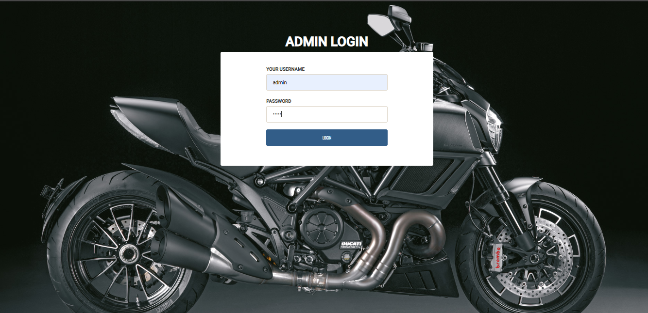

**USER LOGIN**

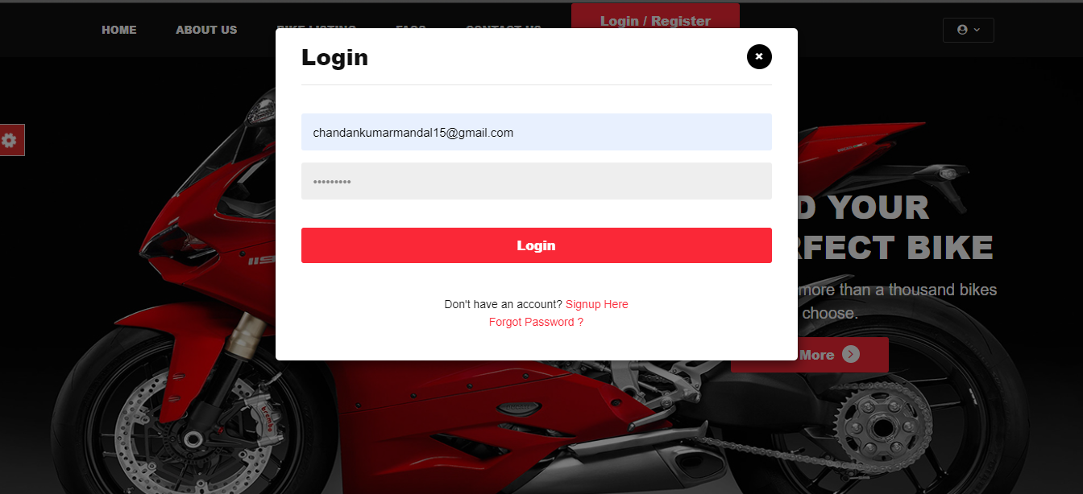

**ADMIN_DASHBOARD**

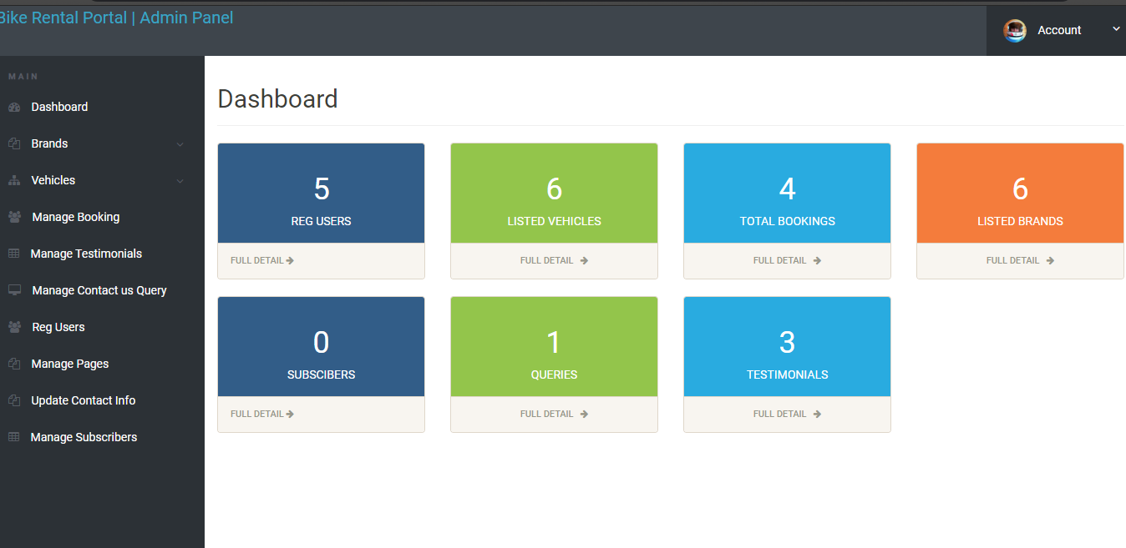

**Add Bikes Brand**

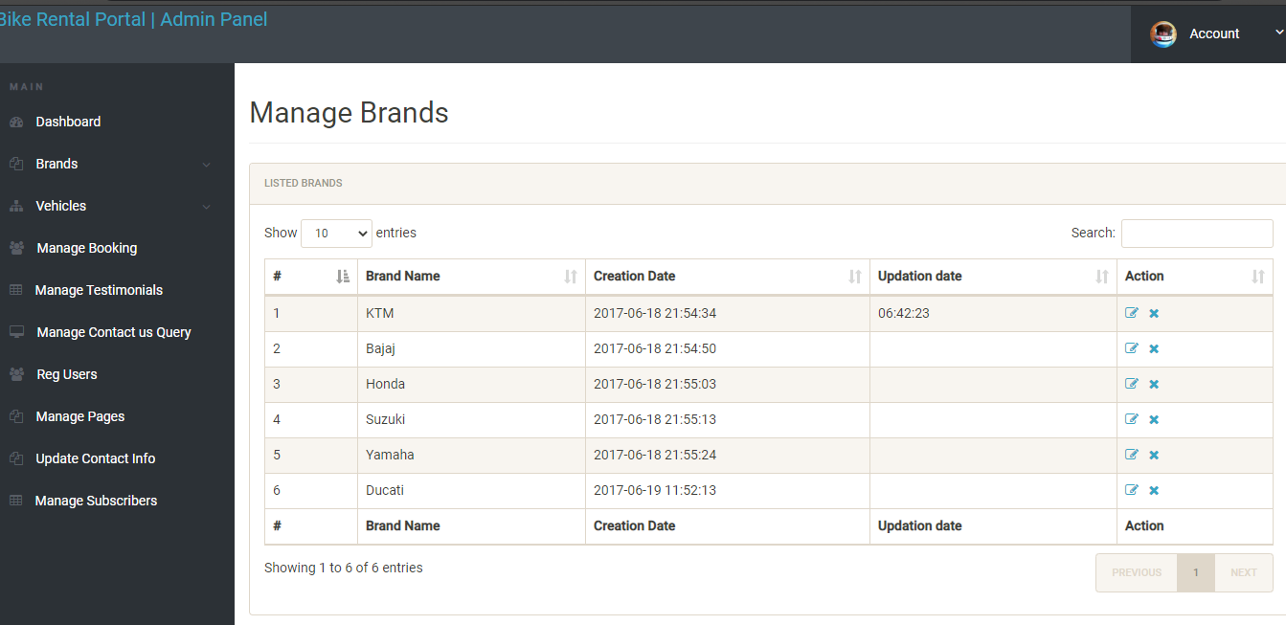

**Manage Booking**

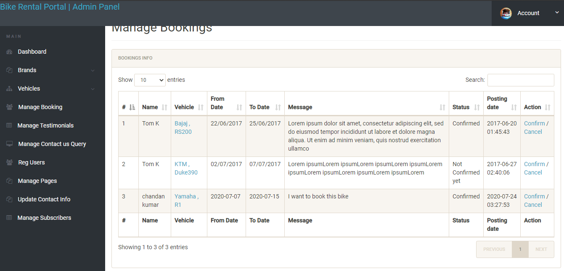

**Manage contact us Query**

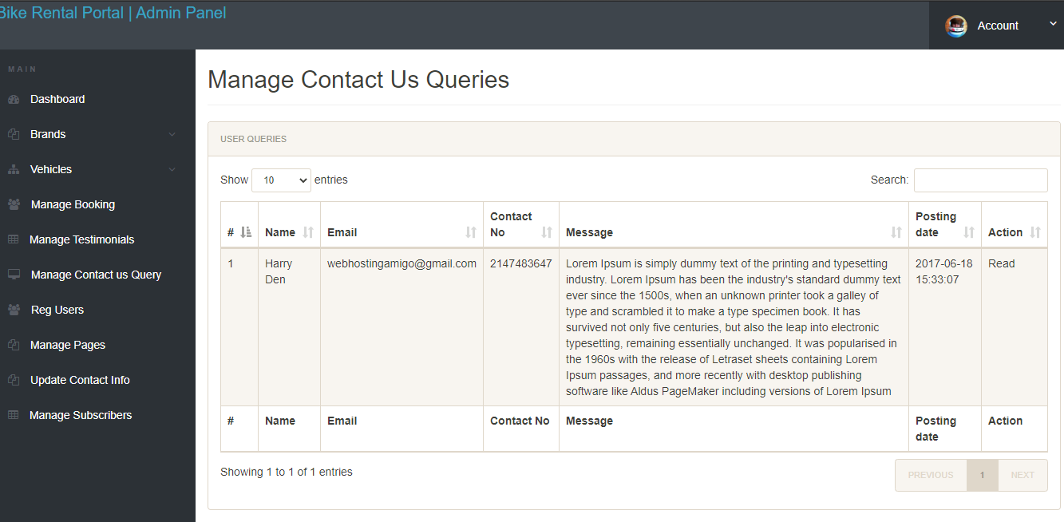

**Manage Testimonial**

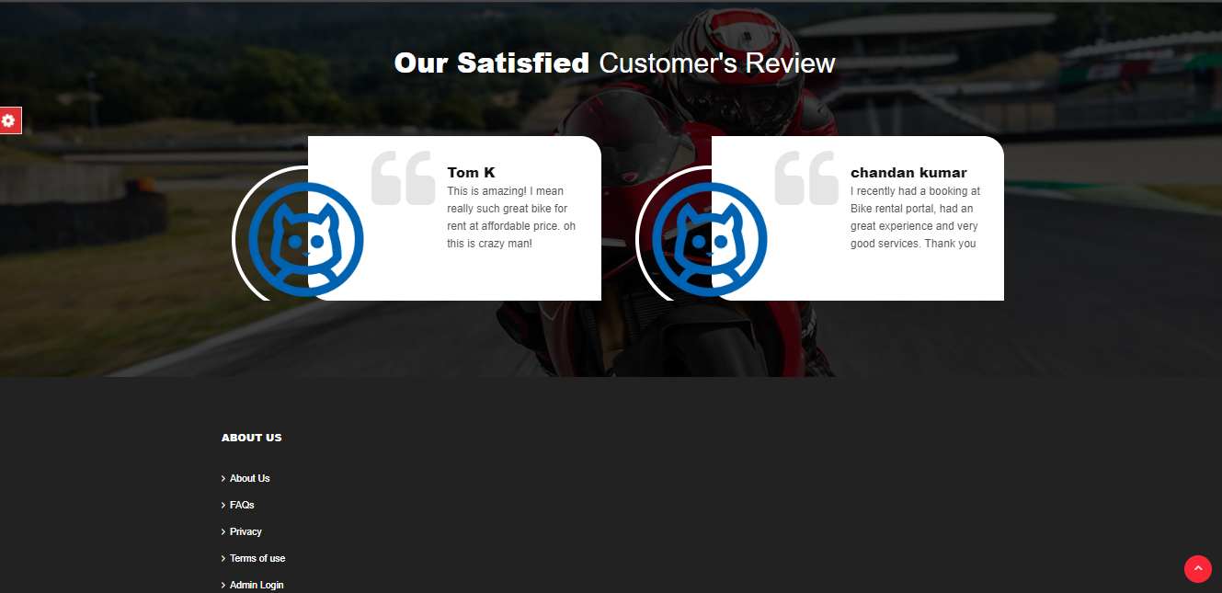

**Register Users**

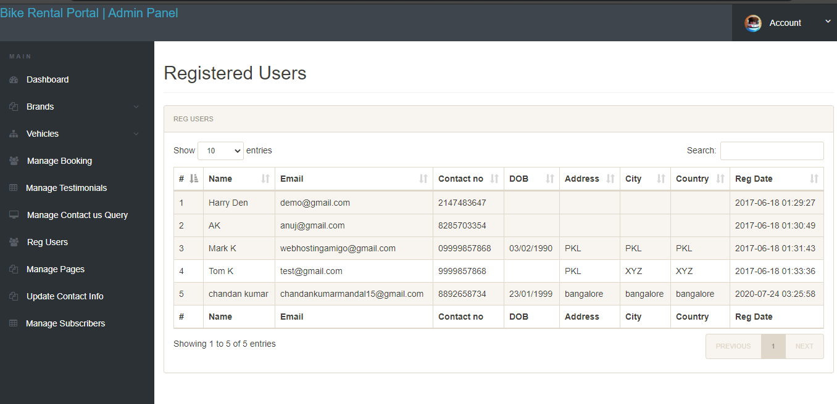

**User Homepage**

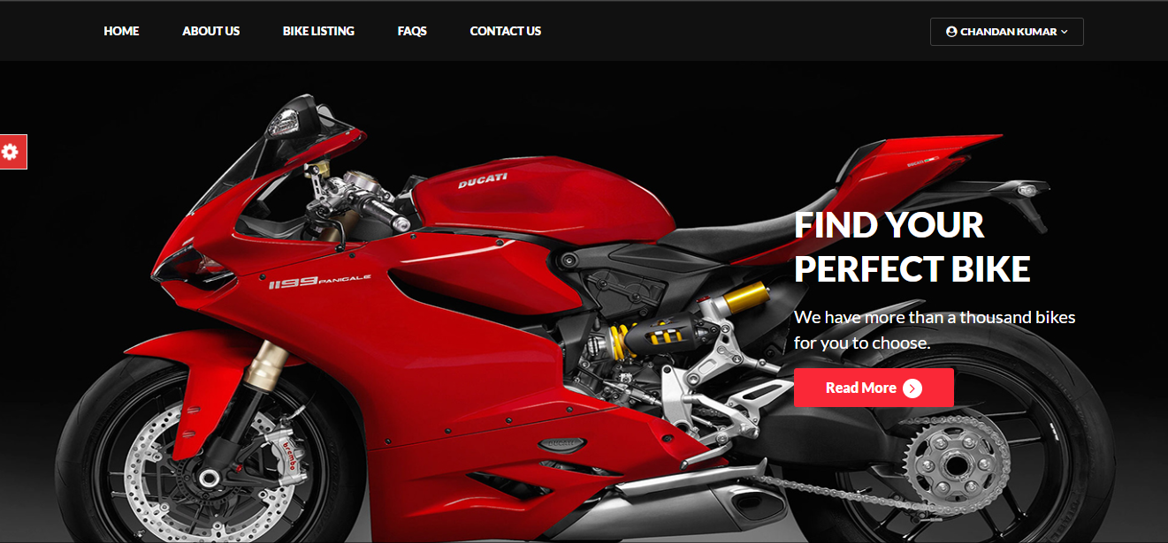

**Bike Listing**

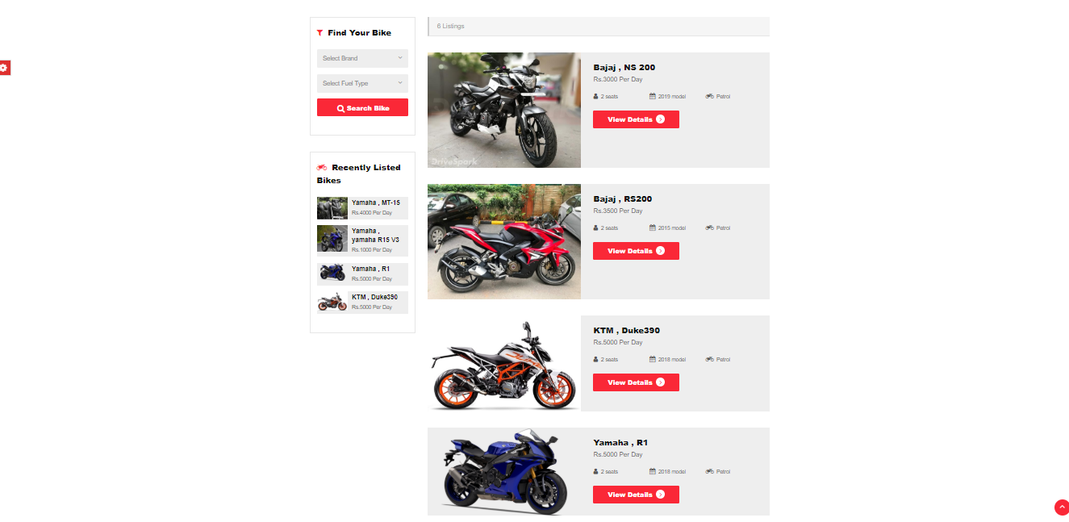

**Bike Details**

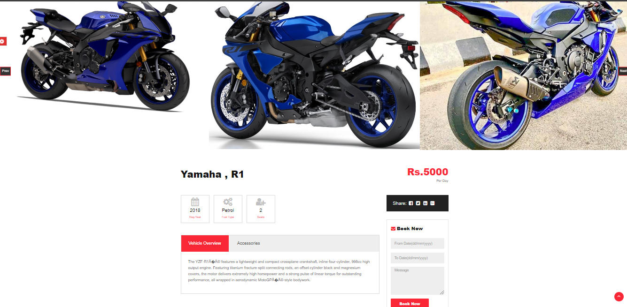

**FAQ**

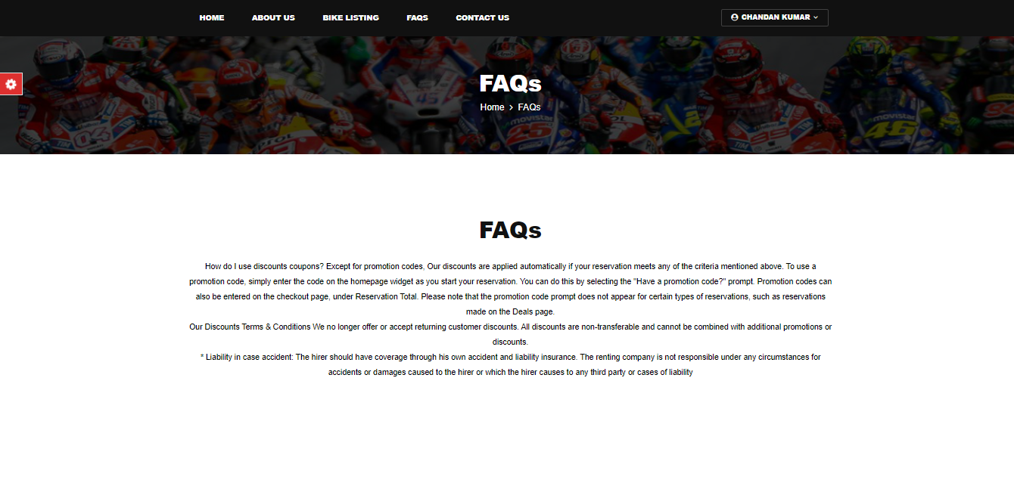

**About us**

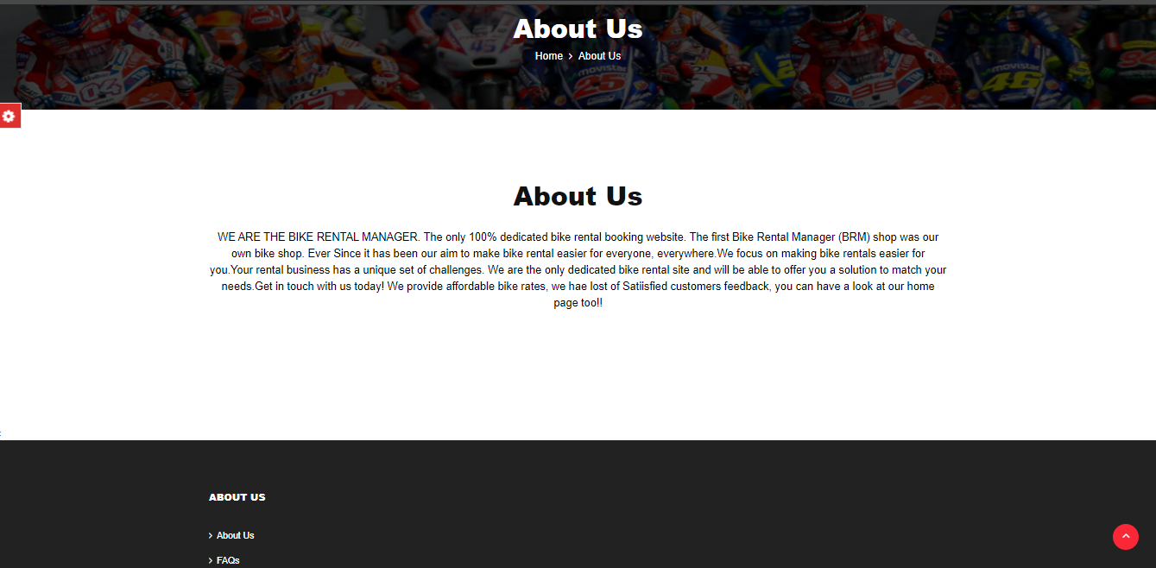

**Send Message**

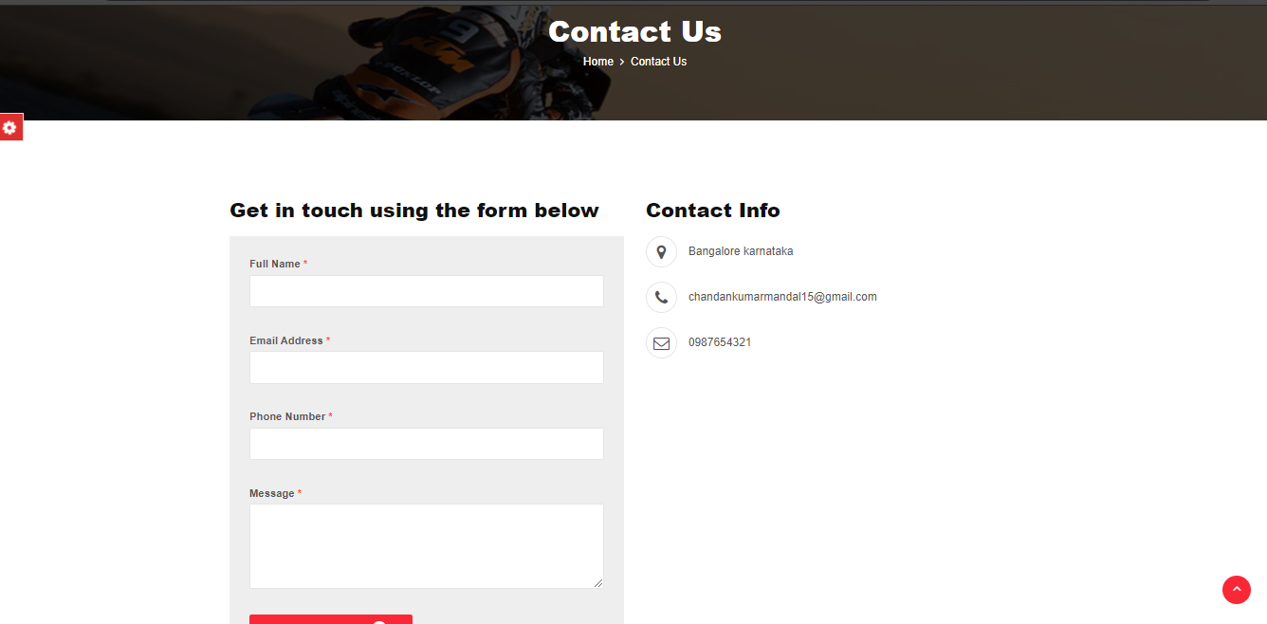

**Change Password**

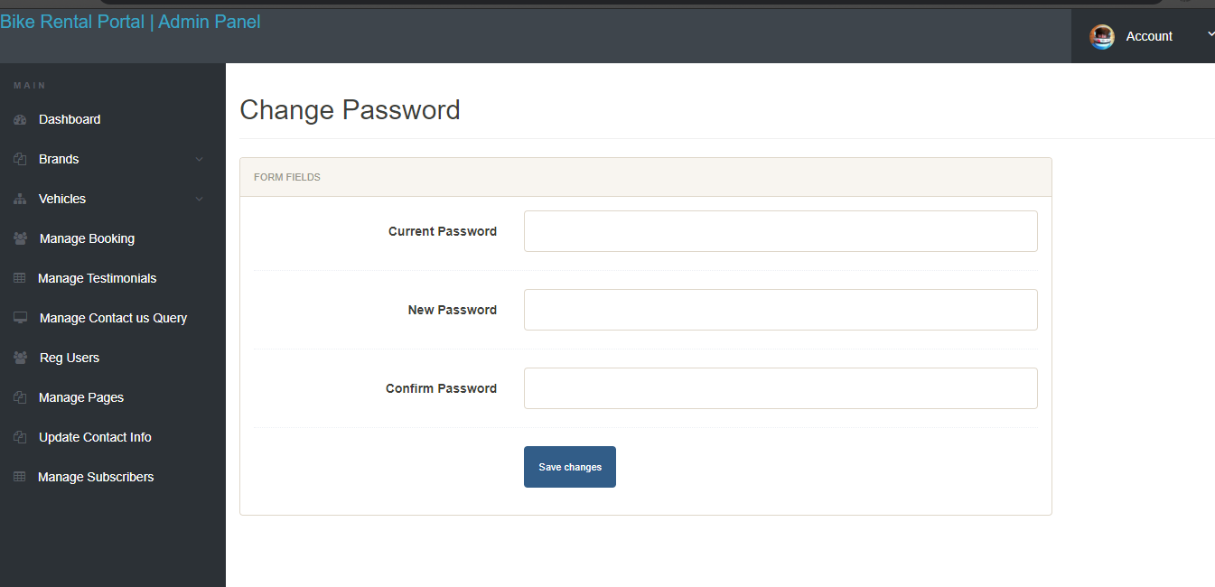

**User Profile**

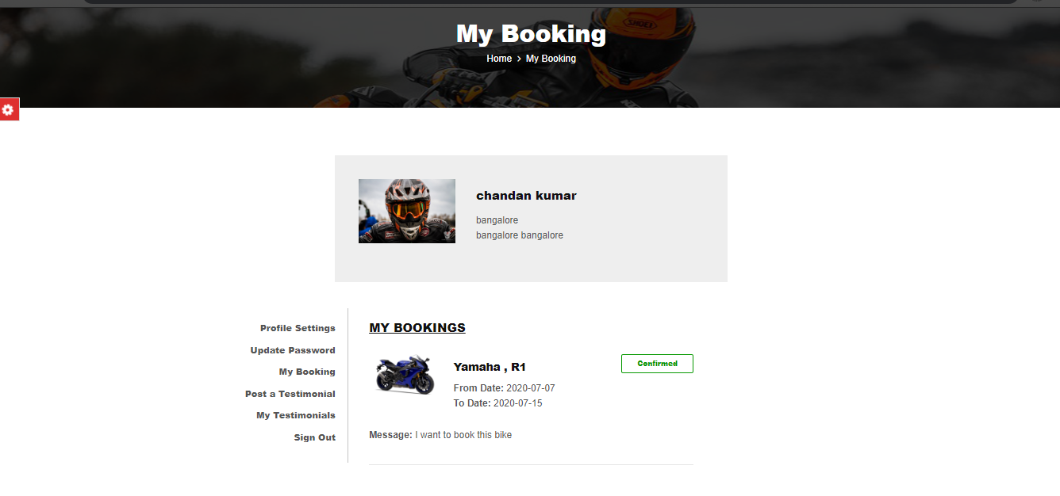

TESTING

**5.1 Test cases**

Software testing is described as the way toward accessing the system or its components with the purpose to find that weather it fulfills the predefined necessities or not this moment brings us the real, expected and the contrast between their outcomes. In straightforward words testing is executing in the system the end goal to distinguish any gaps errors or missing requirements in spite of the genuine desire or prerequisites.

* **Validation testing for the project**

|  |  |  |  |  |  |  |
| --- | --- | --- | --- | --- | --- | --- |
| TEST ID | | INPUT FEILD | INPUT VALUE | VALID TYPE | EXPECTED RESULT | ACTUAL OUTPUT |
| VTI | | MOBILE NUMBER | 4676GDFGH | INVALID | 10 DIGIT NUMERIC VALUES ONLY | AS EXPECTED |
|  |  | 91+4569875433 | INVALID | 10 DIGIT VALUES ONLY | AS EXPECTED |
|  | |  | 9876543210 | VALID | FURTHER  PROCESSING SCREEN | AS EXPECTED |
| VT2 | | EMAIL ID | EXAMPLE@GMAIL.COM | VALID | FURTHER PROCESSING SCREEN | AS EXPECTED |
|  | |  | CHANDAN | INVALID | FORMAT SHOULD BE FOLLOWED | AS EXPECTED |
| VT3 | | PASSWORD | ****** | INVALID | INCORRECT PASSWORD | AS EXPECTED |

CONCLUSION

CONCULSION

The Bike RentalManagement System is developed using HTML, CSS, JavaScript, JOucry, Ajax as Front-End , and MySql(PhPinYadmin), Apache/XamppServer as Back-End And Language used is PHP. It fully meets the objectives of the system in which it has been developed. The system has reached the study state where all the bugs have been eliminated. The system is operated at a high level of efficiency and all the users associated with the system understand its advantages. The system solves the problem, it was intended to solve. The system is flexible and changes if any can be made without much difficulty. Every step has been taken to make the working of the project comfortable as possible for the users.

The Major Advantages Are

• Easy retrieval of data available in database.

• User-friendly UI.

• Does not require large amount of memory.

• Very less manual work is needed.

• It is Dynamic and Flexible.

FUTURE ENHANCEMENT

This project can be updated in future as and when requirements for the same arises, as it is very flexible in terms of expansion. Proper consideration has been given for enhancements in future throughout the development of the software. But the system can be extended, as the software is constantly evolving and always has a scope for future enhancement.

The current system was mainly designed to support the management of the organization and User. In the future, this system can be enhanced to include online Payment, current system has not included such a provision. All the functions have been done carefully and successfully in the software, and if any development is necessary in future. It can be done without affecting the design by adding additional modules to the system.

• Online Payment, to help users not to worry about carrying cash.

• Expanding of Branch.

BIBLIOGRAPHY

TEXT BOOK REFRENCES

1. Julie c meloni, “sam’s teach yourself PHP, MySQL and apache all in one” fourth edition ,pearson education.
2. Bear Bibeault, yehuda katz, “JQuery in Action” 2nd edition, manning publications.

WEB REFRENCES

1. Google.com

2. http://w3schools.com

3. http://Youtube.com